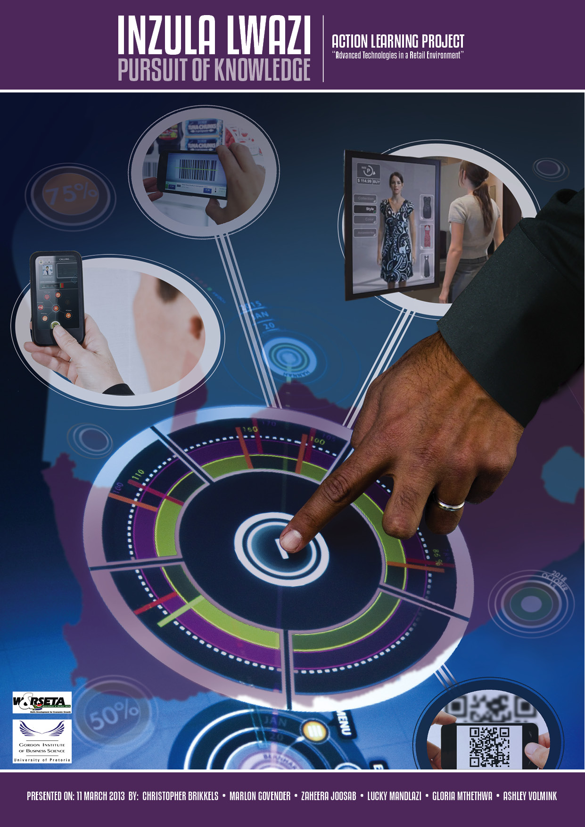

**TABLE OF CONTENTS**

**CHAPTER 1: STATEMENT OF PROBLEM** 3

1.1 Executive Summary 3

1.2 Prelude 4

1.3 Opportunity Statement and Objectives 5

1.4 Research Methodology 5

**CHAPTER 2: LITERATURE REVIEW AND INTERNATIONAL RESEARCH** 6

2.1 Introduction 6

2.2 Mobility 6

2.3 Radio Frequency Identification (RFID) 8

2.4 Digital Signage 8

2.5 Augmented Reality 9

2.6 Wireless Networks 9

2.7 The Management of Big Data 10

2.8 Location Based Marketing and Interactivity 11

**CHAPTER 3: IMPACT OF THE ADOPTION OF ADVANCED TECHNOLOGY ON OPERATIONS** 12

3.1 Impact on Products 12

3.2 Impact on Shelves and Signage 12

3.3 Impact on Checkout 12

3.4 The Evolving Retail Environment 13

3.5 Limitation of Advanced Technology in SA 13

3.6 Profit and Cost Implications of Advanced Technology on Business 14

3.7 Business Case Principle explored 16

**CHAPTER 4: ADVANCED TECHNOLOGY IN RELATION TO THE CUSTOMER** 17

4.1 Customer Insights and Competitor Landscape 17

4.2 Empowered Customer, Customer Experience and Loyalty 18

4.3 Impact on Legislation 20

**CHAPTER 5: BUSINESS CASE AND RECOMMENDATIONS** 21

5.1 Business Respond

5.2 Business Context Model

5.3 Recommendations

CONCLUSION 25

LIST OF REFERENCES 26

ADDENDUMS 29

**CHAPTER 1**

**1.1 EXECUTIVE SUMMARY:**

Advanced technologies have undeniably influenced the world's culture in the past few decades. Technology has brought about a change in customers’ expectations which calls for transformation in terms of the customers' shopping experience offered by retailers. These technologies allow companies to develop better customer service and support processes.

Access to internet through Mobile devises like cell phones, tablets, etc. is putting pressure towards retailers as customers expect to shop at their own time not prescribed by trading hours and they use all forms of shopping convenient to them. To determine what technology is necessary to implement, a retailer needs to think about the following: how their current technology meet their employees and customer accessibility needs; can employees effectively communicate and collaborate to meet the business and customer needs, etc.

Although the impact of the deployment of advanced technology does not always deliver a “direct” financial return on investment, it has a direct impact on competitive advantage for businesses, e.g. with Electronic Shelf Edge labelling – flexible and strategic pricing through dynamically adjusting prices to customer and competitor requirements; increase in sales volume per person for In-store Mobility System, etc. When management discuss ROI of an IT investment they should not only focus on the financial benefits but the competitive advantage it would give the business such as customer experience, improved productivity, efficiencies, which would result in quicker turnaround time.

We engaged leading business retailers, knowledge experts, and customers across all LSMs including unions and we found that 80% of South African Customers are willing to shop digitally, 41.3% of South African Customers said they rely on store Digital Signage to locate products in the store. 50% said Technology makes their shopping experience easier and enjoyable. 28.3% of South African consumers says Technology in the South African Retail Market is not on the same level as other countries and only 24.7% customers says local Retailers are taking advantage of technology to enhance their shopping experience. 47.7 % of South African customers have also indicated that they would prefer online shopping for their future shopping whilst 27.3% would prefer shopping by using cell phone and mobile wallet when buying and or paying for their merchandise.

Although mixed feelings still exist from unions on the implementation of technology there is a strong view that technology will enhance efficiencies resulting in improved customer relations. The current South African reality is retailers need to integrate relevant technology within their business to stay competitive as summed up in this statement “As we move into the future, companies without relevant technology integrated within their businesses will not be able to survive the turbulent markets that lie ahead, only the deployment of advanced technologies will enable SA Retailers to create relevant Value Propositions and thus create sustainable profitability.”

* 1. **Prelude**

In this document, the authors explored how international retailers have deployed available technologies and how they have improved the customer touch points, thereby creating an improved customer experience, customer retention, and ultimately profitability. The authors have further explored how these technologies are transforming the retail landscape and the complexities associated with deployment and integration. Quoting Bill Gates, *“*[*The first rule of any technology used in a business is that automation applied to an efficient operation will magnify the efficiency. The second is that automation applied to an inefficient operation will magnify the inefficiency.*](http://thinkexist.com/quotation/the_first_rule_of_any_technology_used_in_a/200048.html)*”*

Through the International (United State of America, Canada and United Kingdom) immersions, the authors were exposed to a broad spectrum of advanced technologies in use by the retailers in these countries. The authors brings to light how these technologies impacts the various aspects of a retail operation at the same time pointing out the pros and cons of employing these technologies. We will be looking at amongst others the impact of products; shelves and signage, payment at the tills, impact on the current level of partnerships and collaboration that is within the retail sector in South Africa.

The other aspect that the business review part of this paper will cover is the impact of the employment of technology on the financial aspect of the organisation. It will cover not just the cost implications but also the importance of measuring the value that advanced technologies will bring which may not necessarily be financial in nature.

The role of advanced technology in the business end of the retail sector is certainly of great importance, which enables businesses to effectively and successfully plan, manage, execute strategies which lead to profit. Moreover, the impact of advanced technology on business is on the rise, as several advancements that are focused on in this paper will no doubt be implemented in various business processes in the near future.

Daniel Levine pointed at a South African Council of Shopping Centres Annual Congress that, “The future of retail around the world‚ including in South Africa‚ is inextricably connected to technology and the internet”. For this reason, retailers cannot afford to turn a blind eye and disregard technology especially in relation to customer shopping experience considering customers around the world, including in South Africa are becoming tech-savvy. Retailers today are facing many challenges including the way the customer wants to be engaged to the way they want to shop. There are increased expectations for retailers to meet this need without compromising on service delivery, profitability and overall sustainability going into the future. “Best practices tend to be built on the proper use of technology, taking into account what technology does and what it does not do, and what it was intended to do” (Curry, 2008). Retail technology is evolving and so is the modern customer. They expect their shopping experience to be tailored to their specific needs. Whilst technologies exist to enhance the customer experience, it also provides retailers with opportunities to accelerate employee productivity, increase revenue and keep data secure.

Retailers are looking for better ways to understand their customers and deliver the right products, through the right channel, at the right time and at the right price. Retailers are paying particular attention to leveraging data and new technologies to optimize demand side processes, attract and retain more customers, and drive future growth. Access to more product information, along with a wide option in the range, has shifted power to the consumer, resulting in higher customer expectations. To create marketplace advantages in the future, retailers will need to know their customers intimately, including their needs, wants, preferences, and values, and re-design their business processes and in store technologies to ensure customer expectations are fully satisfied. In order to achieve these results, retailers will need to adopt a new mind-set which entails the adoption of relevant technologies for improved customer shopping experience. Successful retailers will be those that make use of these emerging technologies and implement and be in tune with the evolving retail environment.

**1.3 Opportunity Statement and Objectives**

**1.3.1 Opportunity Statement**

The significance of specific advanced technologies in ensuring that South African retailers remain competitive with the constant change in customer requirements.

**1.3.2 Objectives**

In addressing the opportunity statement, the authors will:

* Explore the manner in which retailers can deploy available and emerging technologies in order to transform the business process and subsequently impact positively on customer experience, customer retention, and ultimately profitability;
* Explore how the current technologies are transforming the retail landscape and the complexities associated with deployment and integration;
* To highlighting new trends and opportunities for the South African market.

The specific research outcomes are as follows:

* What technologies do customers want to use in the store to improve their shopping experience?
* What should leaders be considering when it comes to choice of technology and deployment?
* What kind of skills do retailers in South Africa require to facilitate advancement of technology within stores and ultimately an improved customer experience?

**1.4 Research Methodology**

The qualitative approach was used to collect primary data. Interviews were scheduled with 8 leadings business retailers. Appointments were set up and the responses of each interview were transcribed.

The method and approach are both qualitative and quantitative in nature. In completing this research, the authors relied on the following research tools:

1. Conducting interviews with, retailers (Woolworths, Makro, Builders Warehouse, Ellerines, Pick ‘n Pay), knowledge experts (technology vendors and technology leads at the mentioned retailers), customers and other relevant stakeholders to capture the relevant conversations and extract the required detail needed for problem articulation and recommendations. The authors will explore how companies keep on top of the rate of change and how these companies deploy these technologies to meet the business process requirement.
2. The use of various information centres such as GIBS to conduct research.
3. Through a process of immersion the authors will be were exposed to leading retailers (Wal-Mart, Macy’s, Loblaws, Woolworths, Makro, Builders Warehouse, Ellerines) thinking and strategies with regards to advanced and emerging technologies.
4. Through interviews (Woolworths, Makro, Builders Warehouse, Ellerines, Pick ‘n Pay) and on-line surveys, (for the South African context).

The qualitative approach was used to collect primary data. Interviews were scheduled with 8 leadings business retailers. Appointments were set up and the responses of each interview were transcribed. Through a process of immersion the authors will be exposed to leading retailers thinking and strategies with regards to advanced and emerging technologies.

1. Through interviews and on-line surveys, (for the South African context) the authors will seek to understand:
   * 1. What does the retail customer expect and how does this inform change within the business process?
     2. What does the modern retailer need to transform in his current business in order to accommodate advanced technology?
     3. How would emerging technology meet the needs of the future retailer?
     4. What are the potential obstacles to implementing new and emerging technologies?

**CHAPTER 2**

**LITERATURE REVIEW**

**2.1 Introduction**

The initial research and international industry immersion has highlighted that despite the advancements in information technology (IT), retail shopping remains fairly technology free. There is an indication that the retail customer is becoming more tech savvy and that shoppers may want their shopping experience enhanced through more personalised customer experience. Provided that the return on investment can be proven, it will be realised that retailer’s adoption rate for these technologies will improve.

Currently retailers have vast options of advanced technologies available to enhance their business. These technologies include Radio Frequency Identification (RFID), digital signage, wireless networks, automated receiving, finger scanning, QR codes, electronic shelf edge labels, kiosks, augmented reality, facial recognition technology, surveillance camera technology to monitor customer behaviour and a host of mobile solutions which have been explored under the banner of mobile centricity. Whilst a host of technologies exist, the study has chosen to highlight a few current and emerging technologies that will refocus the way retailers do business.

**2.2 Mobility**

The world is advancing from a web centric to a mobile based centric IT. Mobile devices and applications are creating a new web thus creating the opportunity for retailers to maximise on their efficiencies and ultimately improve consumer satisfaction and gratification by integrating into the retail space**.** During the international immersion at a meeting with IBM, the idea of mobile centricity was explored. Retailers should invest more in mobile channel as more consumers want to go mobile for shopping. According to the 2012 Smarter Consumer Study released by IBM, consumer desire for using mobile devices while shopping more than doubled (138%) within the past year. The survey focussed on consumer purchasing trends and shopping habits of 1800 UK consumers. Shoppers are demanding a more personalised, convenient and budget friendly shopping experience with the aid of mobile technology. Other key statistics was reported as follows:

* 39% of the customers said that they want to use mobiles to receive personalised promotions;
* 42% want to use mobiles to seek out lower prices;
* 44% to seek out promotions;
* 42% to locate products in store;
* 39% of consumers rely on websites for comparative shopping; and
* 83% of consumers prefer to research online prior to browsing for a product during an in-store visit.

Linked to the global survey by IBM, it seems that consumers are willing to share their personal data with retailers so that they can receive services tailored to their preferences, location and lifestyle. The supporting statistics are as follows:

* 75% are willing to share their information about media usage;
* 73% with regards to demographics;
* 61% for personal identification such as name and address;
* 59% for lifestyle; and
* 56% for immediate location.

Martin Butler, a leading retail industry leader, IBM UK and Ireland, supports this argument by saying that mobile technology is set to change the 4P’s of marketing – product, price, place and promotion as “personalisation" becomes key. A white paper published by Motorola, states that consumers are always-on and connected to the world around them and this always-on connection provides a virtual explosion of new ways to touch customers. Retailers can leverage these connections with today’s technologies to create an unprecedented real-time connection to customers. This connection allows an organisation to leverage the many new available customer touch points. A business is then transformed from channel-centric to customer-centric, enabling the creation of dynamic pathways inside and outside the store to meet the needs of the new connected customer.

**2.2.1 Mobile Wallets**

The deployment of the mobile wallet has begun and already there are many different definitions for the term in circulation. The term ‘mobile wallet’ points to similarities with a conventional wallet but the word ‘mobile’ refers to the main characteristic that a traditional leather wallet lacks: connectivity. Mobey Forum (Mobey Forum, White Paper A: 2012) defines a mobile wallet as “functionality on a mobile device that can securely interact with digitized valuables”.  This is a deliberately broad definition. A mobile wallet of the future could conceivably contain all manner of payment mechanisms which to us, at this early stage of the technology, are unfamiliar. In order for the mobile wallet to give the end user the maximum benefit, Mobey Forum (Mobey Forum, White Paper A : 2012) believes it should operate as an open platform.

In research conducted during the immersion, Dave Rogerson (Retail Industry Marketing Manager, IBM America) states that mobile centricity is the platform that most retailers should adopt, stating: "Mobile technology has the greatest implication on retailers. The purchase of tablets and smartphones already exceed those of PCs since 2010. They are the device that will enable retailers to engage consumers in a full multi-channel experience. They are also the device most likely to drive changes in marketing campaigns, types of currency accepted at the point of sale, and challenges in terms of data acquisition and integrity". Further to this, Andrew Kinnear (Senior Digital Strategist, AIMIA) also backs this up and stated during the immersion that Mobile centricity is the platform into the future and should leverage this along with the added benefits that this media has to offer in terms of location based marketing and interactivity also as vast opportunities to concept.

Examples of these wallets are Google Wallet and Apple Passbook (launched with the new iPhone 5 in September 2012).

**There are four primary models for mobile payments:**

* Premium SMS transactional payments;
* Direct mobile billing;
* Mobile Web Payments (WAP); and
* Contact less Near Field Communication (NFC).

Mobile payment is being adopted all over the world in different ways. Combined market for all types of mobile payments is expected to reach more than $600b globally by 2013 which would double the figure as at the end of Feb 2011, while mobile payment market for goods and services, excluding contact less NFC transactions and money transfers are expected to exceed $300b globally by 2013.

The notion of smart phones acting like a credit card is fascinating, and a number of stories are published about mobile payment- enabled smart phones and the potential rise of PayPal, Google Wallet and such as the new payment processors. Even if MasterCard and VISA were somehow to let go of their Billion-dollar processing business, it would merely be a replacement of one financial processor with another.

The fact that a smart phone could act as a card is absolutely genius. It is defined as mobile payment/ mobile money/mobile transfer, and mobile wallet generally refer to payment services operated under financial regulation and performed from or via a mobile device. Financial institutions and credit card companies as well as internet companies such as Google and a number of mobile communication companies, such as mobile network operators and major telecommunications infrastructure and handset multinationals have implemented mobile payment solutions. This is an alternative payment method instead of paying with cash, cheque or credit cards, a consumer can use a mobile phone to pay for a wide range of services and digital or hand goods.

**2.3 Radio Frequency Identification Device**

The Radio Frequency Identification Device (RFID) technology is not a ―"new" technology. RFID applications have been in existence for more than a decade in one-chip configurations and even longer in less integrated technology. Common well known and proven applications that use Radio Frequency technology include: Contact less cards used for control of access to buildings and other secure areas; Electronic tolling for roads; Automatic ticketing systems and Animal identification.

The ultimate goal in retail is to create RFID systems that provide the benefits of the technology at a cost that supports item-level tracking. Such item-level tracking would provide each unit of inventory with a unique ID. When RFID was originally launched adoption rates were slow as a result of associated costs to deployment, however these costs are reducing and retailers are beginning to invest more in the technology. RFID is listed as a technology that has been available for over fifty years already ([www.technovelgy.com)](http://www.technovelgy.com)). However the reason it has taken so long to come into common use was as a result of a common technology standard across the industry so that company to company and country to country tracking could deliver tracking benefits. During the International immersion and discussions with various retailers, it still seems the adoption rate is still slow however the consideration for using the technology is being actively discussed, especially on high value items.

**2.4 Digital Signage**

One of the more interesting and evolving technologies is use of digital signage. It incorporates a variety of technologies used to replace traditional retail signs. Instead of static print signs and billboards, digital signage is composed of electronic signs dispersing content and messages in the most targeted, interactive way. A company called 3Di-Solutions mentioned that the customer interacts with images be it two or three dimensional with specific data linked to it. In other words the customer can obtain real time product knowledge, location and available information. The technology has benefits and risk considerations attached to it which are not associated with static displays. Dynamic variants of the signage can grab a customer’s attention and influence a purchasing decision at the point of purchase. It has the potential to reduce cost of creating, printing and distributing print ad campaigns. An added benefit is that it allows retailers to on-sell advertising space (to non-competing organisations) on their digital signage network to increase the return on investment. Whether the intent is to build the brand or provide a unique shopping experience, the potential for sales increase is there.

Clinton Groves states that this technology takes a significant effort to scope, install and manage. To operate effectively it needs to work in harmony with the business’s operating, advertising and marketing model. The business content needs to be standardised with purpose based designs. In a meeting with Amy Alexandra, Marketing Manager for Whole Foods Market London - Piccadilly Circus, this point was confirmed. At Whole Foods their Store Department Leads have access to the company’s content management system where they can promote and advertise product in their respective areas. In these stores staffs are sent for training on the system. This is a very different approach to most companies that drive this activity centrally. Other considerations are environment and location and that inappropriate positioning will deliver poor results. Digital signage is expensive both from a hardware and support perspective. Choice of support vendor is critical so that service levels remain optimal thereby not impacting the customer negatively. If these systems are not integrated into existing systems appropriate slow performance and systems downtime will impact the business negatively overall.

**2.5 Augmented Reality**

Another fascinating concept adopted by a company called 3Di-Solutions in Canada, was augmented reality. In effect it is digital imagery pasted on the real world and has certainly earned the attention of the advertiser and the consumer. This technology is used as virtual fitting rooms where customers can try on garments without needing to physically fitting the garment. Whilst Macy’s in New York was said to have used this technology, the visit to this store revealed that the technology has been removed. The staff on the sales floor could not confirm why, however there was an indication that it was not used that frequently. This was one of our first pointers to the fact that technology should not just be deployed for the sake of technology, but should link back to the customer needs and desired experience. The online research however has revealed that this technology is being used in retail. For example, clothing retailer H&M can hold a virtual photo-based scavenger, while New York Giants fans can virtually try on the Super Bowl XLVI championship ring and share the photos online. These all talks to enhancing the customer experience. It is clear that augmented reality in its current state is still young and developing and it certainly has the potential to also change the future of retail.

**2.6 Wireless Networks**

Wireless networks work hand in hand with some of the technologies mentioned above. These types of networks could allow retailers to invest in a number of emerging retail applications that could make a big store feel small. On the Smart planet website, this argument is supported by mentioning the following capabilities:

* Opt-in customer loyalty applications that help clerks know when a specific person enter their store;
* Analytics systems that help keep tabs on inventory levels, alerting managers when stock needs to be rebalanced;
* Mobile checkout and payment systems that will transform the point of sale experience;
* Product information systems that help customers find out more information about products, escalating those questions to a store associate when appropriate;
* Wireless technology promises to transform the customer shopping experience, providing a powerful competitive tool as retailers strive to build stronger customer relationships;
* Personal digital assistants or other hand-held devices for employees will give them real-time access to product and customer information, enabling them to answer customer questions on the spot. Eventually, hand-held mobile devices will be available for use by customers, delivering detailed product and promotional information directly into their hands. Smart cards will also interact with customers while they are shopping, suggesting products or notifying them of promotions based on their current or past buying behaviour;
* Wireless POS systems will go a step further, combining real-time product information access with on-the-spot checkout services. With voice technology for inter-store communication, links to product and customer databases, built-in scanners and credit/smart card readers, and mobile printers, these systems will not only enable employees to answer customer questions but also complete sales transactions wherever the customer may be in the store. Inzula Lwazi team experienced this first hand while shopping at Planet Food in London.

**2.7 The Management of Big Data**

Byron Banks, Vice President for Product and Marketing for SAP says that today’s retail businesses are real time information driven enterprises. Every customer interaction and movement of a product through a distribution network is measured and used to refine pricing strategies, update inventory decisions and tailor customer incentives on websites, email and mobile devices. He also states that maintaining long-term, profitable customer relationships requires a constant two-way flow of information between the retailer’s storefronts, their suppliers and distribution network. The best retailers have been using mobile capabilities, Big Data technologies and advances like in-memory computing to revamp their business processes. They are accessing information sources that didn’t exist before or were too costly or complex to use to become more nimble, cost competitive and able to delight customers with outstanding selection and service.

In the authors meeting with the Central Group in Canada, one of the technologies discussed was the ability to monitor the customer’s behaviour in a store using surveillance cameras and heat map applications. As most retailers have a key challenge in detecting and measuring lost sales or lost opportunities. If retailers can understand why a customer looked at a product but did not buy it, they are more likely to adjust product selection, pricing or some aspect of displaying to see if the behaviour of the shopper changes or the sale is realised. This can be achieved through customer analytics and profiling. An example of how this could work is that the customer is identified as she walks into the store. She is then tracked through positioning systems within the store. Through video footage or heat mapping technology (as seen at the Central Group in Canada), her browsing behaviour and shopping behaviour can be analysed. One can understand that this is a lot of information to process especially if one extrapolates against the number of customers (hence the term Big Data). Post analytics can then message the customer through various channels to offer her alternatives or provide feedback from her around product offering.

The same technologies can be used in conjunction with RFID and distribution networks to improve supply chain processes and ultimately customer experience service levels. This ability allows retailers to map incoming orders, real time traffic information and truck locations to improve delivery service levels. An example of an organisation that has implemented a solution such as this is the online grocer Fresh Direct. The analysing of multiple streams of data as a prediction or forecasting tool is also a competitive advantage. Understanding and knowing customers buying patterns allows the retailer to market directly to the customer real time through email or a mobile communication of potential promotions on a product he/she may need in a couple of days.

Our discussions with industry experts who understand the Wal-Mart business confirms that this retailer processes huge amount of data to find out which products consumers are talking about. Wal-Mart uses free software called Hadoop, which was created by a group of Yahoo developers to analyse raw information better than traditional databases. An article by Dwight de Vera called “Big Data in Retail – Big Ideas for Better Retailer Performance”, confirms that Wal-Mart keeps track of products, sales and customers to such a degree that it uses petabytes of data to win pricing concessions from suppliers. The article also highlights that by embracing big data analysis, US retailers can increase operating margin by up to 60%. The improvement impact for retailers has been in the following areas:

* Marketing Strategy :segmenting customers into groups based on extremely granular things;
* Store Layouts : determining which products perform best on a shelf;
* Product pricing optimization : figuring out which goods to place on sale at particular times;
* Labour cost optimization: with store labour accounting for as much as a third of a retailers fixed costs.

According to industry forecasts the worlds volume of data doubles every 18 months and all forms of data will grow 650% over the next five years. If retailers do not embrace the trend and data analysis that comes with the management of Big Data, they will not remain competitive. A report published by McKinsey Global Institute (2011) mentions that the use of big data will underpin new ways of productivity and growth and consumer surplus. They believe that a retailer using big data to the fullest has the potential to increase its operating margin by more than 60%. Whilst managing big data has huge benefit, it does come with its own set of complexities. The cost of the hardware to manage huge data sets and environments is significant. There will be a shortage of talent necessary for organisations to take advantage of big data. The McKinsey (2011) report highlights that by 2018, the United States alone could face a shortage of 140 000 to 190 000 people with deep analytical skills as well as 1.5 million managers and analysts with the know-how to use the analysis of big data to make effective decisions. Other concerns around policies related to privacy, security, intellectual property and even liability will need to be addressed in a big data world.

**2.8 Location Based Marketing and Interactivity**

Locative media or location based media are media of communication functionally bound to a location. Location based media delivers multimedia and other content directly to the user of a mobile device dependent upon their location. Location information determined by means such as mobile tracking and other emerging real-time locating system technologies like WIFI or RFID can be used to customize media content presented on the device. A locative medium are digital media applied to real social interactions and is in existence for less than five years.

With this technology one could deliver a powerful marketing content that drives a message and in turn increase sales, without overspending, is referred to as Geo-targeting, area location based marketing.. Marketers, Business Owners and consumers agree less area is more. Location based marketing isn't about jumping on the bandwagon but effective utilization of the tools will assist retailers to leverage the additional sale and becoming more relevant in the advanced world as customers today are techno savvy and empowered. The Next Generation Customer demands to see red tape and wants instant gratification. The inception and exploitation of this avenue has enormous benefits to customers who demands and are entitled to instant gratification. Location based marketing meets this need vigorously. Mobile applications allow information to be available to these techno savvy customers, giving information on store location, products and benefits as well as specials in that particular area where applicable.

These applications are highly effective and Retailers who have seen the benefits are drawing direct correlation to increased sales and ultimately broader consumer base with positive spin-off. In the aspect of negativity the issues are dealt with and highlighted thus enabling the Retailer to react positively and utilise learning’s effectively.

In addendum 9, we have presented 3 of our responses on surveys posted to technology specifically with mobility consideration are a “must” for the retailers. The responses also indicate the fact that vendors and technology partners are confident that these technologies are mature enough to deploy within the retail context to deliver business value and an enhanced customer experienced. In general the sentiment expressed was that retailers need to make maximum use of the technology opportunities whilst the customers are still in the store whilst not being too invasive in their personal shopping space. The total number of responses that we received on this specific survey was 3.

**CHAPTER 3**

**IMPACT OF THE ADOPTION OF ADVANCED TECHNOLOGY ON OPERATIONS**

**3.1 The Impact on Products**

After reviewing the different types of technologies that are being used in the retail sector of the developed countries, the focus shifts to the business consideration of the use of technology. This will cover both the impact on operations and the financial impact. Any change in infrastructure is costly, thus retailers require adequate backup support to ensure the right developmental choices are made when implementing advance technologies in-store.

**3.2 The Impact on Shelves and Signage**

The challenging days of incorrect shelf pricing, empty shelves, missing signage and unmanned counters, are all huge problems as old as retail itself. This translates to lost sales and worse a lost customer which compounds the lost sales instance. The advent of Augmented Reality, Digital signage and Electronic Price Labels promise the beginning of a new era in retailing and will deal with the challenges experience in retail stores. While some of the initial hardware set up and software maintenance costs make these advancements seem impossible to adopt, it is believe that as soon as it is utilised more, costs will come down drastically. This will see retailers starting to reap the benefits of many enthralled customers being attracted to their stores. Mobile phones create the possibility to make shelves and signs into interactive points within the store. Currently, interactivity in-store means heavy investment in kiosks. Adopting the use of mobile phones is sensible as it makes the most of investment in this area.

**3.3 The Impact on Checkout**

Given the complexity of current checkout systems, it’s no surprise that retailers are reluctant to make fundamental changes. Retailers should explore the business benefits of integrating new technologies at checkout, particularly when they have an impact on customer experience, such as reduced queue times. If integration is not seamless, retailers clearly risk creating problems for employees and customers alike. Clearly, demonstrating return on investment is essential. In the short term, retailers should examine how they are best equipped to read 1D bar codes or enter corresponding numeric codes displayed on mobile phone screens In the longer term, they should look at future interactions at checkout involving contactless technologies. The ultimate goal is an internet-enabled checkout that is able to interact with and contribute relevant data streams for the benefit of the retailer’s own business as well as its suppliers and consumers.

**3.4 The Evolving Retail Environment**

Over the years, retailers have realized tremendous value in creating an infrastructure that caters for future additions and developments, for example S.A.P implementation in Massmart. However, seamlessly integrating new technologies and services into current infrastructure represents a growing challenge. This challenge has been compounded by the inherent weaknesses of current infrastructures being inadequate. Large, centralized enterprise information systems generate massive amounts of data, such that the said data cannot be used effectively for accurate and timely store action. In order to use the data at all, retailers have created rigid structures that are so inflexible, that they are in turn, forcing the retailers into rigid operating models. Retailers are constrained in bringing new products to market, introducing new store formats, and reaching out to the customer in new and creative ways. The value of actionable insight based on real-time item information at the store level will drive the next great wave of value creation for retailers, FMCG manufacturers, and, ultimately, customer. As new technologies emerge to service the retail environment, these technologies must take into consideration that actionable insight will not be gained by the aggregation of low-level data. In fact, insight is all about the emergence of new ways of thinking that come from managing data, combining and recombining itself into something new. Then, in order to be of the most value, insights need to be accessible and actionable at a local level for real-time execution.

The authors believe the only way a business can proceed is to recognise that the fundamental infrastructure will not be changed in the short-term, therefore new technology needs to be flexible enough to be integrated with what currently exists. For most retailers, the biggest challenge is to have an appropriate processes for fulfilment (from processing orders electronically through to delivery) that is integrated with the rest of the businesses. In order for Advanced Technologies to be implemented effectively in the South African market, it will be critical for the various stakeholders to work together to embrace and shape the vision in the way forward. To shape this vision and make it reality, businesses must ultimately collaborate and find ways to share information efficiently right down to the consumer or the deployment of these technologies will fail,

In addition, the successful introduction of emerging technologies at the store level dictates that retailers should look outside their own IT teams for assistance. In the past, retailers were reluctant to seek the help of outside experts to address their IT challenges, but in the last five years, there has been a growing trend toward IT outsourcing in the retail industry. Presently 40% of retailers outsource some element of their IT infrastructure or business processes.

**3.5 Limitations of Advanced Technology in South Africa**

The following are seen as limitations to South Africa:

• Not all customers are equipped with the current advanced technology. Differences between handsets and networks can mean high costs to develop services for a large number of customers. As South Africa has a larger lower and middle income market when compared to retailers in the USA for instance, mobile device management and services aggregation on the back end potentially becomes a complex consideration as not all South Africans are in possession of the modern smartphone. Our group thought around this after engaging local technology companies, was that each retailer targets a specific market and should therefore deploy relevant technologies which that market would engage in. The customer and loyalty systems remain the same it’s just the technology touch point that changes. We have however seen how local technology companies such as SQIM becoming innovative around offering customer basic value add experiences such as mobile balance enquiry across a large devices in one retail organisation;

• Use of proprietary technologies makes integration with existing systems difficult and costly; and

• Differences in supporting infrastructure in retail store are a barrier to mass market rollouts.

**3.6 Profit and Cost Implications for Advanced Technology**

The retail industry on a never-ending quest to increase revenue and decrease costs. Technology has been an area of intense focus in retail as a way to accomplish both goals. Improvements have been made in areas such as supply chain management, inventory management, customer experience, and loss prevention. Wireless technology, permitting communication between people and devices anywhere and without cables, has enabled the dramatic transformation of business processes in the past, and continues to do so. However, wireless deployments in the past have been limited by security requirements, the cost of deployment, inadequate management solutions, lack of standards, and availability of innovative solutions. Rapid advances in wireless local area network (WLAN) technology in recent years along with widespread adoption of the technology in the customers and enterprise space have eliminated many of these roadblocks. Today, a new wave of opportunity exists for retail industries to improve margins through the use of wireless technology. Hence, it is essential for all businesses to anticipate and plan for the various ways in which new technology can impact on bottom-line financial figures. Factors that need to be weighed include tax laws, long-term budgeting, and current financial health. Depreciation tax laws for software and hardware are complex, which lead many consultants to recommend that business owners use appropriate accounting assistance in investigating their impact. Once new technology systems are in operation, business owners and managers should closely monitor financial performance for clues about their impact on operations.

The authors engaged leaders on what should be considered when it comes to introduction and deployment of technology. Responses from Google Canada referred that organisations need to ensure that the choice of technology and partner ties into the path of purchase. If it does not, organisations run the risk of spending vast sums of money for a technology that may not enhance the customer experience. This outcome supports the argument and research to date that the customer experience roadmap informs choice of technology and subsequent investment. Responses from Richard Garvin (director at Total Retail), also stated that retailers also potentially need to consider acquiring other companies that specialise in technology or outsourcing the specialised work completely. Another response from Inez Blackburn (Central Group – Director of Research), states that apart from the integration components which could be complex and costly, many firms have examined these costs in depth and have seen that these investments can be far greater than any measurable benefits, especially taking into account the variety of systems, vendors and consultants. Based on the above it does seem that when IT professionals and senior managers discuss return on Investment (ROI) of an IT investment, they look at the financial and non-financial benefit. In other words, customer experience, information benefits and quicker turn-around times become agenda items.

The following is an example of the limitations business face in the implementation of technology. The Canadian example is used as narrative to illustrate the point.

**Figure1**[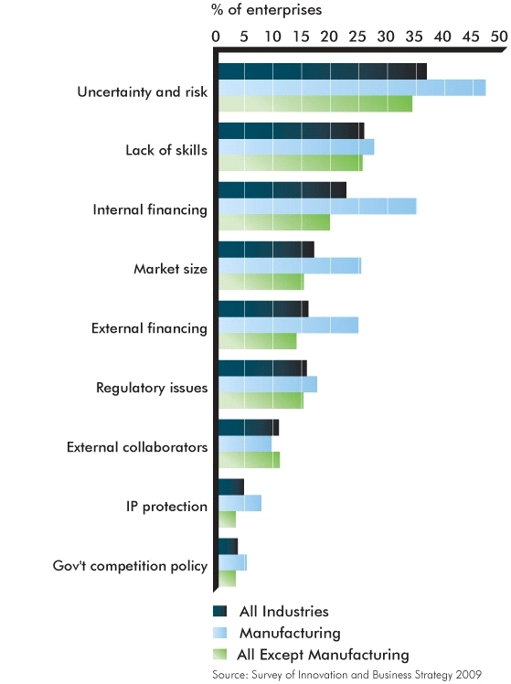](http://www.ic.gc.ca/eic/site/eas-aes.nsf/eng/ra02100.html)Source ([www.ic.gc.ca](http://www.ic.gc.ca))

Based on the analysis of the above diagram it is apparent that external financing (16.2%) and regulatory issues (15.9%) are obstacles to innovation for less than 1 in 5 businesses in Canada. Except for the issue of finding external collaborators, a greater proportion of enterprises in the manufacturing sector reported facing obstacles to innovation relative to other sectors of the Canadian economy. ([www.ic.gc.ca](http://www.ic.gc.ca)). Retail remains digital as the vast majority desire to shop and to browse with an expanding number of technologies. Taking into account the consideration stated above which links business benefit to return on investment, the authors can draw a conclusion that based on the research to date that it’s not always a financial benefit that relates to the decision to invest in technology within a retail environment. Taking this observation into account it is clear that retailers have to invest in technology to ensure an improved customer experience and retention. Whist digital and online shopping activity has increased, a study conducted by IBV Retail (2012) which focuses on which technologies consumers are willing to use, assuming they are available, mobile solutions should be a key consideration when the investment decision is posed. The study reveals that 80% of consumers in South Africa are willing to shop digitally with 38% of those consumers using 3 different types of technologies.

**Figure 2**

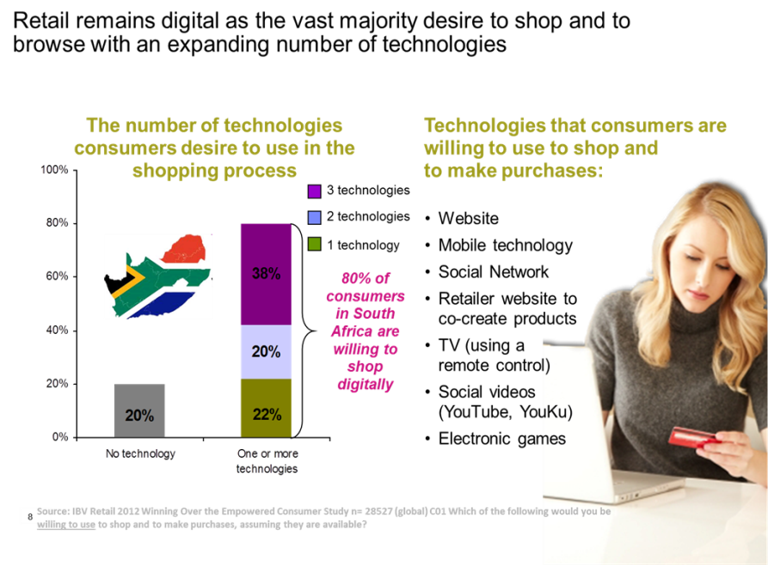

Based on a process of scanning the environment, an obtaining research data from various sources, the authors focus on understanding customer centricity within the context of technology and mobility the decision to invest in solutions such as mobile is not only paramount but linked to organisational sustainability as a return on investment measures.

**3.7 Business Case Principles Explored**

Our research has highlighted the key principles and metrics required to meet the business case requirements of related technology implementations within the retail environments. It has also become clear that the returns might not always deliver the pure financial returns but generally the customer experience factor becomes a key component when facing the decision to invest.

Whilst the principles and metrics may be generic in nature, the required technology investments are certainly not and these need to be considered against the existing IT architecture of that organisation and plays a big role when making the decision to invest. These considerations were very apparent throughout our research and discussions with technology implementation partners.

Our research has shown how CTM (South Africa’s biggest tile and bathroom retail) invested 10.6 million Rand in a hand held point of sales solution implemented by Britehouse Mobility resulted in a **50% increase in sales volume per person** and an **80% reduction in the time needed to do stocktaking** and was rolled out to 86 stores. Tim Meara, the IT manager for CTM parent, Italtile Limited said that their stock is heavy and often bulky and customers can’t easily push a trolley around in a store. There was a need for the store staff to focus on consulting as well as to know which store product could be sourced if not available. In the past they had to move to computers in the front of the store to look up stock levels, prices and perform grout and tile adhesive calculations. The process was time consuming, inaccurate and could cost the customer money through overestimation and not having real time information on hand. The handheld device allowed the staff to do everything with the **customer on the floor** in a **fraction of the time**. **Customer satisfaction** metrics improved and the CTM benefits where being able to **process more sales in less time**, sales people were equipped to give **better advise/service** and provided them the **ability to cross sell**. Additional **cost savings and efficiencies** were achieved in **stock taking**, **automatically checking variances** and the ability to **post data directly into CTM’s ERP system**. In this case, CTM’s top line strategy was to improve the customer experience. In this particular implementation the key principles and considerations were:

* A realisation that mobility is the next big technology for business because it exponentially increases the efficiency, speed and accuracy of the collection of use of data
* The technology allowed for the enforcement of related in store processes as well as standardisation on how the customer was serviced, the products were positioned and brand conveyed
* All operational elements that could be mobile driven were defined
* The technology implementation partner (Britehouse) worked closely with the organisation (CTM) to understand existing and new architecture landscape. This included the decision to use in store Wi-Fi platforms as opposed to using a national cellular system. This has a security benefit to CTM and cut out the need to manage cellular service provider contracts.
* They deployed modular solutions so that benefits could be realised quickly.
* The implementation partner also had an understanding of the ERP solution which made solution integration points easier.

The CTM/Britehouse case study was a very relevant one for Inzula Lwazi as it touched on all the technology areas we were researching. There were also some analogies and references done back to our own organisations as each organisation were at different points on their technology roadmaps. In the case of Woolworths, they are in the process of defining their store of the future strategies and have implemented some technology in their Nickelway store in Gauteng. In an interview with one of the IT business partners, the technology considerations were at foremost an opportunity cost to improve the customer experience and the considered technologies did not have a direct link to any additional revenue streams at this stage. There would be some cost savings but point of sale mobile related strategies and process automation were there to alleviate some pressure for stores. Some of the labour (time sensitive) processes that they were looking at for operational acceleration were replenishment, fault reporting, alerting for product related issues, task management and stock receiving (truck location real time).

Considerations mentioned around the deployment of mobile solutions for customer related engagement as well as store processes were:

* Mobile Device management which is a cost that general gets overlooked when deploying solutions. This talks to servicing and upgrading of multiple devices
* When provisioning apps for these devices, can future updates be catered for
* Mobility linked to customer centricity needs to be backed by very capable CRM (customer relationship management) solutions as these ultimately manage your loyalty components as well.
* The access and use of ever growing data is becoming for important (Big Data).

In the case of Tradeport distribution, the organisation is seeking to grow their business, however in store advanced technologies and mobile solutions have not been considered up till now. Back end (ERP) systems are being matured and the organisation is well placed for creating significant change by implementing the right technologies. Trade port’s considerations are as per addendum 10.

**CHAPTER 4**

ADVANCED TECHNOLOGIES IN RELATION TO THE CUSTOMER

**4.1 Customer Insights and Competitive Landscape**

The world has become a global village; particularly within the business world .Businesses should not only be concerned about their internal matters but also every local and international business that operates within more or less a similar target market. Dr Albert A Vicere, (Strategic Leadership: Driving Innovation and Change, Pennsylvania State University) highlights this in his paper among other things, the importance of ‘looking out’ to the world in-order to be aware of patterns and new trends that could have an impact on your business; he also refers to ‘looking around’ which would assist in keeping positive momentum of a business lifecycle e.g. ensuring you have prophets within your business to ensure they search for new ideas, technology, etc.

Technology is a big contributing factor towards globalisation and this places a high demand on businesses like retailers to conform to global standards. Further, pressure towards retailers comes from the new age customer who is tech-savvy. This customer shops at his /her own time (not prescribed by retailers opening hours), uses all forms of shopping convenient to them, whether by visiting a store, shopping on-line and have their goods delivered to them or collecting at a time convenient to them from the retailer.

There’s a greater need for the SA retailers to be more customer-centric and focus in understanding, the Empowered Customer, Customer Experience and Customer Loyalty in order to gain competitive edge.

In an age of technologically savvy and increasingly smarter consumers, who are increasingly connected with each other through a number of mobile devices, tablets and applications, retailers understand that competing on product and price are unsustainable strategies for success. Customers seek and accept shopping advice from peers, family, friends and even strangers. And through this lens of connectivity and collaboration which enables them to know almost everything about every product and brand – these “smarter” consumers ultimately decide which retailers have earned their trust.

**4.2 Empowered Customer, Customer Experience and Loyalty**

It is important for retailers to understand the customer’s path to purchase. The question then becomes is there one path to purchase that customers follow? What is that path, if any? The authors have discovered through International immersion that there is no single customer path to purchase. With the accessibility of mobile technology, customers have various options. They may choose to physically visit a retail store for shopping but while at the store be comparing prices with other retailers selling similar merchandise using their mobile devises; they may choose not to visit a store but shop on-line and have their goods delivered at work or home, the possibilities are endless.

**What does the above mean for the South African Retailer?** With the understanding of the environment within which the South African Retailer operates in, a blanket approach in the adoption of technology would be pointless and costly.

Unlike most businesses, “Retailers suffer from both the blessing and the curse of large numbers. Anything implemented across 2000+ stores is expensive; The cost of new technology often relies on new infrastructure that retailers simply didn’t build into their stores, e.g. most retail shelves do not have electrical power nearby, much less RFID scanners and Wi-Fi nodes...” John Ross, Shopper Science CEO Retail Technology and the Revolving shopper.

Unlike in the developed countries, the lack of fast speed internet is a challenge in South Africa. Hence retailers need to have an understanding of their customers and the environment they operate in. A store like the Woolworths in Woodmead serves as a good example. It could introduce mobile check out (like seen at Whole Foods market, London Piccadilly Circus), considering that the shop caters mostly for executives who work within that area during weekdays. A store like Checkers in Sandton City is busy and caters for customers shopping in a rush during office hours. It could introduce “in-store price scanning” and “self-check out till points” (like seen at Wal-Mart in Pennsylvania – State College). Where the latter would possibly differ within the South African environment would be to ensure stringent security measures in light of the prevalence on petty crime in South Africa.

The Woolworths and Checkers mentioned above could even introduce on-line shopping and opt to deliver at offices around their vicinities.

The graph below has been extracted from a survey conducted in the United States of America indicating what customers see as added value in terms of their store experiences with different technologies. Even though South Africa is lagging behind in terms of technology uptake – the retailers need to shape up as the South African customer is adopting technology at a fast pace and are aware of what customers in the other countries are exposed to technology wise.

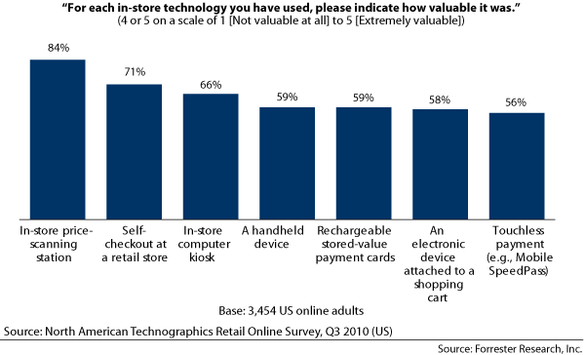

We have surveyed over 300 South Africans within LSM 3 to 10 over a period of three months. Since the low and high end of the LSM groups is world apart, we needed to understand how the different consumers perceive technology and the role it plays in enhancing their shopping experience. The lower LSMs have minimal access to technology whereas the higher end is more exposed to it in lots of different ways. The technology needs within the different LSM groups would differ. Our study has shown that our local customers are aware of technologies and whilst they believe that South African Retailers are using technology to better their shopping experience but they also believe that lots more can still be done to better their shopping experience. These customers believe that they will still visit brick and mortar stores for their shopping however technology will play a bigger role in making their shopping more easier and enjoyable.

**Analysis of Customer perspectives**

**4.2.1. Analysis of Household Income**

|  |  |
| --- | --- |
| AGE | HOUSEHOLD INCOME  R3000-R100,000 |
| 18-25 | 4.4% |
| 26-35 | 35.6% |
| 36-45 | 42.2% |
| 45-60 | 17.8% |

4.4% of the surveyed sample were within the age of 18 to 25, 35.6% falling within the age of 26 to 35, 42.2% from ages 36 to 45 with 17.8% from ages 46 to 50 years and they all are within a household income ranging from R 3000 to R 100 000 per month.

**4.2.2. Analysis of in-store Mobility**

|  |  |
| --- | --- |
| Technology | Mobility |
| Easily Navigated | 45.7% |
| Easy Product location | 41.3% |
| No response | 13% |

45.7% of the people believe that they are able to navigate their way easily in the store by using technology, like digital signage. 41.3% are able to locate products easily in the store

**4.2.3 South African technology vs. International standards**

50% of the sample said technology generally assists them in making their shopping experience easier and enjoyable. However 28.3% of South African consumers say Technology in the South African Retail Market is not on the same level as other countries whilst 24.4% says South African Retailers uses technology to enhance their shopping experience.

**4.2.4**  **South African Customer - technology requirements**

47.7 % of South African customers have also indicated that they would prefer online shopping for their future shopping whilst 27.3% would prefer shopping by using cell phone and mobile wallet when buying and or paying for their merchandise. Only 25% of the local customers would prefer shopping using TV remote controls, in the comfort of their lounge watching their favourite TV programs.

**4.3 Impact on Legislation**

Introduction of any technology comes with a number of challenges. Within the South African environment, retailers should also consider the impact of technology being introduced in terms of the legislation and labour laws. In order to have an understanding of the impact legislation has within retailers and the introduction of technology, PCI & POPI and Labour laws & Skills Development must be considered.

**4.3.1 PCI (Protection of Card Information) and POPI (Protection of Personal Information)**

Adoption of technology raises concerns on security of personal information, etc. It is thus of high importance for South African retailers to have an understanding of PCI and POPI policies and procedures in order to ensure protection of their customers. For an example, customer loyalty programmes entail storing and usage of big data. Consequently cloud computing raises concerns that data could be easily stolen. In turn, this puts customer’s personal information security into a serious concern for both retailers and customers. Retailers need to ensure secure dissemination of customer’s data. This further raises concerns on how retailers could take advantage of what technologies like e-wallets has to offer customers to better their shopping experience. While an e-wallet allows a customer a faster payment

option without having to input their banking details, it raises a concern that on registering for an e-wallet, the data could possibly be stolen which puts customers’ banking details at risk. Consequently, the retailer is likely to find it difficult to make a decision on whether to invest in such technology infrastructure.

**4.3.2 Labour Laws and Skills Development**

Without a doubt, in order for retailers to give customers a compelling reason to be loyal, skills development becomes an important part in the implementation of new technologies.

The South African Retail industry needs to invest more in young talent and scarce skills. With the adoption of new technologies within store environments comes a responsibility to impart relevant knowledge concerning such technology. With an organisation like W&R Seta having taken a centre stage in ensuring skills development within the sector – retailers need to work closely with them in ensuring this is achieved to the benefit of themselves, customers and their workers. Like the winning formula that Marks & Spencer has used – retailers need to ensure a buy in on all levels of staff. Fast track young emerging talents in key roles and enforce the use of a new technology.

**4.3.3** **Labour/Union Perspective**

Though mixed feelings still exists from unions on the implementation of technologies but there is a strong view that technology will enhance efficiency and results in better customer relations. They believe that though implementation of technology may also impact negative in that it may replace human labour they believe that there is a need for technology. SACCAWU Union members say more training is needed on technologies and employers needs to take more precautions when implementing technology. They believe technology will make their members work smart, it will improve competency levels. They also believe that skills levels on products needs improvement in South African Retail Market.

There is a reasonable acceptance by Unions of the urgent need of technology to better customer’s shopping experience and these can only be achieved if consultations with labour and training are offered on technology. 50% of our local customers believe in technology and this is as a result of different life styles and personal commitments which make time to be of great value to the customers therefore it is important for retailers to shorten the time spend of the customer in a store by best usage of technology. Implementation of best technology has a potential of converting 50% of customers to a rand value through the usage of best and relevant technology. The next challenge will be to identify the best technology which will results in store transformation, customer retention and to drive store profitability.

**CHAPTER 5**

**BUSINESS CASE AND RECOMMENDATIONS**

**5.1 Business Response**

Innovative businesses are setting their sights on a clear objective of increasing profitability by focusing their entire business on customers. This seems to have been assisted by capitalizing on the deployment of advanced technologies. This openness to the acceptance and deployment of advanced technologies has allowed these forward thinking companies to reach out to a techno savvy customer whilst enabling employees to become more efficient. The result is a superior customer experience that increases the value proposition of the business. This has enabled them to become businesses that are fully focused on the customer and thus capable of providing a totally smooth customer experience that binds in customer loyalty and ensures that they are always a step ahead of their competitors.

Our international immersion has consistently proven that technology is a key component for a successful retail business, hence we have come to the conclusion that the story that needs to unfold for SA retailers can be summed up into this statement.     “As we move into the future, companies without relevant Technology integrated within their businesses will not be able to survive the turbulent markets that lie ahead, only the deployment of advanced technologies will enable SA Retailers to create relevant Value Chain propositions and thus create sustainable profitability.” Turbulent markets refer to the fact that customers are seeking value and a unique experience. Taking product and service out of the equation, technology evens out the “playing field” as the opportunity to adopt and invest is there for all retailers as technologies become more relevant. With the onsite of strong online retail offerings and new international players entering the market the technology adoption scenario becomes a serious consideration to ENHANCE and provide VISIBILITY to the existing product and service offering. The international players enter the market with back end and customer facing solutions that are already matured. They have agreements in place with their technology partners that contract the maturing of these technologies over time and with cloud computing offerings there are no boundaries barring local legislation. If anything, the technology adoption and deployment stance creates the opportunity and channels to GET TO KNOW YOUR CUSTOMER BETTER.

**5.2 Business Context Model**

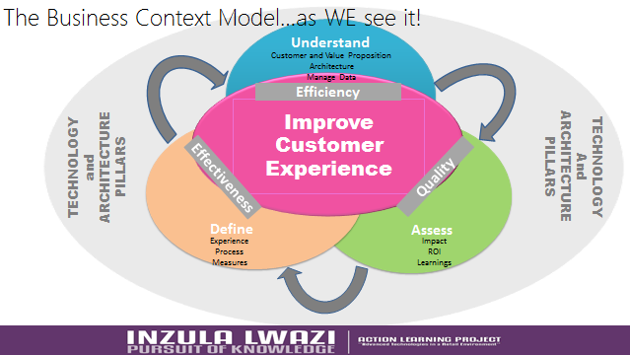

**5.3 Recommendations**

With the advent of a turbulent, changing and challenging retail environment, the question that needs to be asked by SA Retailers is this, “What can we do to drive comparative store growth while still being profitable and creating value in such an environment?” In a recent lecture given to the ILDP 2012 class by Richardo Machado, he summed it up beautifully by the following statement, “Incremental changes in a store or business will no longer be sufficient to survive. A radical mind-set change by the brick and mortar store with regards to the customer shopping experience is necessary.”

SA Retailers do not have the luxury of spending years forming committees and debating whether they should adopt new technologies or not! With every month that goes by they are already losing pace with their customers who are already starting to adopt new technologies and change their shopping patterns. In our retail immersion to the first world countries it is clearly evident that the non-traditional retailers have already started to pick up huge chunks of market share by providing innovative customer experiences and exposing gaps in service and offering, by traditional retailers. We see the perfect example of this with Amazon.com who have climbed up on the Top 20 List of top retailers in the world, and also rated the number 1 retailer in the world in 2012 for service by Forbes. SA customers will soon, not behave and interact with the traditional store as the only touch point with the retail business, instead the store will become one of many options the customer will take and be able to interact smoothly and seamlessly with other channels and touch points, and thus enhancing the overall retail brand and proposition.

There are 3 key areas that we would like to suggest which all retail companies will have to address.

5.3.1 Redefine the value proposition of the store/business. (For Immediate Action)

• Take immediate action to understand your changing customer requirements and expectations.

• Review the role of each channel and how they create an overall brand proposition.

• Determine the role that each individual unit (store) within the business plays for the customer and determine the strongest individual value proposition for each unit.

It is of vital importance to start with the customer and understand how the store is going to fulfil the customer’s expectations and needs. A clear understanding of what the customer’s shopping pattern is across the channels will help to shape and determine the proposition in each store. No amount of adoption of the most advanced technology will help until this first step is executed effectively and efficiently.

5.3.2 Changing the store portfolio.

* Based on the information from the research above and the key driver of the value proposition, the company is to choose the most appropriate technologies that are linked to the value proposition to be implemented into the business. For example, based on Ricardo Machado’s model for differentiation being a key component of an effective Value Proposition, and where one element of the differentiation model is staff. So if we have chosen to be differentiated on how our staff operates as part of our Value Proposition then we may want to invest in each staff member getting IPads to work with. This is how we choose the correct technologies from the very long list in which to invest in, it must fully support our Value proposition.
* Review necessary size, formats and location of stores in the light of the revised channel strategy and store Value Proposition. This is a more drastic component of the solution and should be more carefully phased in over a longer period of time.
* A strict adherence to cost cutting in all avenues. The efficiencies that the deployment of advanced technologies will bring must be optimised and thus cut out any redundancies.

5.3.3 Re-align the operating model.

* We should fully understand the impact of traditional brick and mortar stores now becoming more multi-channel outlets in the integrating of teams, responsibilities and the insights required to understand customers and develop proposition.
* Distribute costs appropriately to reflect a store that is now deploying technologies. No technology should ever be implemented without the ability to roll it out fully; incomplete roll outs can do more damage than not employing technology at all.
* Review necessary realignment of the operating model in terms of processes, systems, people and metrics which may all require adjustments, especially around range; inventory; service and marketing.

5.3.4 The additional steps to the implementation strategy would entail:

1. In the training and implementation plans all needed information, methods and techniques need to be formalised to all employees and partners.
2. Support strategies that cater for the new implementation and ensure that business as usual activities are maintained.
3. The delivery of a plan that highlights the technology roadmap and upgrade path to follow. This is important in the face of the speed of technology advances. The timelines is imperative as technology projects that delay result in potential outdated solutions with no leveraging of benefits.
4. Technology deployment has to be associated with a proper change management approach that considers customer and staff awareness and needs.

**More Key Performance measures AND BENEFITS** which have surfaced for many of the technologies:

1. **Electronic Shelf Edge labelling**
   1. Improved price integrity
   2. Boost in productivity by redeployment of staff to other less time sensitive process (a cut in resource costs was not considered as a result of some of the input from unions)
2. **In-store mobility solutions**
   1. Increase in sales volume per person (as per the Britehouse case study).
   2. Enhancement of the customer brand via mobile applications namely (Google Wallet and Apple Passbook – providing additional tender capability)
   3. The use of Quick Response (QR) codes in the promotion of sales and marketing activities by scanning using smart phone technology. The benefits are realised by the customer scanning the code on the product and either collecting at the point of sale or to having it delivered to a specified address. Cost savings could be realised through trade space reduction, labour redeployment, more efficient processing of transactions and less need for shop equipment such as shelves and trolleys. QR codes can also be used as marketing tools to up sell and cross sell, e.g. additional products for recipes
   4. The benefit of mobility and Wi-Fi in stores can be seen in the connection between the customer and the store via online communication as follows:
      * 1. Shoppers can use concierge services to obtain product information
        2. Customers can gain the advantage of personalised marketing offers and financial incentives (we have chosen to view this from the customer perspective as Richard Machado points out that value creation for the business will follow)
        3. Wi-Fi is becoming the additional competitive edge to engage and improve the customer experience
3. **Digital Signage**
   1. Ability to influence the purchasing decision right at the point of purchase
   2. Ability to sell advertising space to the suppliers
   3. Is has been proven that the dynamic visual experience ultimately increases sales (percentages not defined as it links to content and product)
4. **Radio Frequency Identification Devices (RFID)**
   1. RFID will reduce the labour requirements (or redeploy), to monitor goods movement and inventory flow
   2. Retailers to complement existing systems while gathering more information throughout a supply chain which can be used to improve processes
5. **Automated Receiving**
   1. Reduced labour costs through less human intervention or allowing for redeployment.
   2. Enhanced cross-docking capabilities enabling faster turnaround times for incoming and outgoing goods

**Conclusion**

A fundamental transformation is required by SA Retailers. The trends and dynamics in the industry are forcing a huge change in the role that a store plays. The entire business will need to adapt to support the new role of the store and some difficult decisions will have to be taken in defining the organisations new models and to derive maximum benefit from the store portfolio. Those team members that can recognise and respond to the reality of changing consumer behaviours will survive the turbulent times ahead and emerge as victors in a completely different landscape.

Whilst we have proven that there are technologies that deliver a direct return on investment, it cannot be deployed in isolation of strategy, existing architecture, people and process. We have seen the path of our research journey diverge and then converge ultimately telling a story of technology exploration and its necessary links to customer centricity and customer experience management. As much as it has been a study into advanced technologies in a Retail Environment, it has become very evident that technology considerations should factor in the customer needs and the experience they desire.

**LIST OF REFERENCES**

Alexander, Amy Marketing Manager, Whole Foods Market.*www.wholefoodsmarket.com*

Banks, B. 2012. SAP Software: Big Data for Retail is Flying Off the Shelves,<http://www.forbes.com/sites/sap>

Blackburn, Inez Director of Research-The Institute Retail Innovation and Education.*www.centralgrp.com*

Brenninkmeyer, Hans, Chairman of the Board of Porticus North America and Board Director,Petro-Canada,former CEO of Comark.

Butler, M.2010. *The Art of Being Chosen: Secrets of Success from the Giants of Retail.* United Kingdom: Management Books 2000 Ltd

CGI Group Inc. 2004: White Papers: Ecosystem – Effectively managing the Evolving Retail Ecosystem, [www.cgi.com](http://www.cgi.com)

GS1 Mobile Com. 2011: Mobile in Retail: White Paper: Getting your Retail Enviroment Ready for Mobile. Available on: [www.gs1.org](http://www.gs1.org)

Clancy, H. 2012. Contributing Editor Smart planet: Retail 3.0? Mobile Technology is both Bane and Boon to Retailers,<http://www.smartplanet.com/blog/business-brains>

Cohn, Alexandra, Senior Industry Analyst, Google.

Curry, B. & English, B. 2008. *Microsoft ® Office SharePoint Server 2007 Best Practices*. Sebastopol, CA: O’Reilly Media.

Cross, Christine, Chief Retail and Consumer Advisor, PWC

Daniel Levine‚ “South African Council of Shopping Centres Annual Congress in Durban” as obtained from an article written by Zeenat Moorad, Future of retail linked to technology‚ internet 2012, Bizcommunity available at http://www.bizcommunity.com/

De Vera, D. 2012. Business Intelligence Blog: Big Data in Retail – Big Ideas for Better Retailer Performance, <http://www.forbes.com/sites/tomgroenfeldt>

**Diane J. Brisebois, Canadian Retail Report:** State of Retail, 2011, [www.retailcouncil.org](http://www.retailcouncil.org)

Dr Albert A. Vicere, Strategic Leadership: Driving Innovation and Change, Pennsylvania State University, 2012

ECMA-340 “Near Field Communication – Interface and Protocol (NFCIP-1)” (ISO/IEC 18092)

EDIFICE White Paper Radio Frequency Identification (RFID),2007)

[*www.technovelgy.com*](http://www.technovelgy.com)*.*

Garvin, Richard, Totsl Retail *http://garvintotal retail.com/*

Green, J. 2007. Aruba Networks: Technology Advances in Retail: Improving Margins using Wireless Networks, <http://www.arubanetworks.com/pdf/technology/whitepapers/wp_Retail_advances.pdf>

Groenfeldt, T. 2012. Forbes: E-Commerce Style Big Data Analytics Meet Brick And Mortar Retailers,<http://www.forbes.com/sites/tomgroenfeldt>

Groves, C. 2012. Digital Signage Connection: Key Considerations for a Successful Digital Signage Network. [online] Available from: <http://www.digitalsignageconnection.com> [Accessed 17 September 2012]

Hayden, Gideon Co-Founder,Tradyo[*www.tradyo.com*](http://www.tradyo.com)

Jana. R. 2011. Innovation: Decoding Design – Why does Retail take so long to Evolve? [www.smartplanet.com](http://www.smartplanet.com)

J.Brisebois, Dianne, CEO,Retail Council of Canada

Julie McManus Guardian,http://www.guardian.co.uk/media-network/media-network-blog/2012/aug/21/technology-retail-service-design

John Ross, Shopper Science CEO Retail Technology and the Revolving shopper, http://shoppersciences.net/storage/TheEvolvingShopper_v4_SHS.pdf

Karabus, Anthony, Retail Thought Leader.

Kinnear, Andrew, Senior Digital Strategist, AIMIA.www.aimia.com

Lee, Jennifer Senior Manager, Deloitte

Manyika, J. 2011. McKinsey Global Institute: Big Data: The Next Frontier for Innovation, Competition, and Productivity,<http://www.mckinsey.com/insights/mgi/research/technology_and_innovation/Big_data_the_next_frontier_for_innovation>

McManus, J. 2012. Engine Service Design: Technology in the Retail Sector: Balancing Needs with Capabilities, <http://www.guardian.co.uk/media-network-blog/2012/aug/21technology-retail-service-design>

McMillan Publishers: Encyclopaedia of Business. 2nd Edition – Reference for Business. Burton. S. Kaliski

Mouton, J. 2005.*How to succeed in your Master’s & Doctoral Studies*: *A South African Guide and Resource Book*. Pretoria: Van Schaik

Mobey Forum, White Paper, Feb 2012.

Mobey Forum, White Paper, May 2012.

Pan, J. 2012. Mashable Lifestyle: How Augmented Reality is Shaping the Future of Retail. [online] Availablefrom: <http://mashable.com/2012/06/20/augmented-reality-retail> [Accessed 28 August 2012]

Polinchock,David , Director,AT&TAdworksLab.*http://www.adworks.att.com/lab/*

Reda, Susan, Executive Editor, STORES Magazine.

Richards, Jason, Senior Vice President PepsiCo UK, Ireland and South Africa.

Robertson, Stephen ,DirectorGeneral,British Retail Consortium.

Rogerson, David, Retail Industry Marketing Manager, IBM America.

Sarma, S. 2012. WDM Group – Retail Digital: Consumer Trends – 138% more shoppers want to go mobile: IBM. [online] Available from: <http://www.retail-digital.com/consumer_trends> [Accessed 23 September 2012]

Scites, J. 1995. Best Review: How Can I Successfully Budget for Automation? [online] Available from <http://connection.ebscohost.com/c/articles/9506020486/how-can-successfully-budget-automation> [Accessed 7 August 2012]

Shayton, S. 2012. Brandchannel: Tesco Pushes Retail innovation with Augmented Reality. [online]Available from <http://www.brandchannel.com/home/post/Tesco-Augmented-Reality-112211.aspx>

Spannos. Y. 2011. **Absorptive Capacity and the propensity to adopt advanced technology. Available at:** [**www.inderscience.com**](http://www.inderscience.com) (accessed 6 September 2012)

Stopnicki, Daniel and Priam Givord,Partners,3Di-Solutions.*http://www.3disolutions.com/*

Technovelgy.com. What is RFID? [online] Available from: <http://www.technovelgy.com> [Accessed 17 September 2012]

Wireless Application Protocol, White Paper, June 2000

Zuurbier, Clairre, Workstream Lead, New Channels, Marks & Spencer [*http://www.marksandspencer.com*](http://www.marksandspencer.com)

**ADDENDUMS**

**ADDENDUM 1-Mind Map**

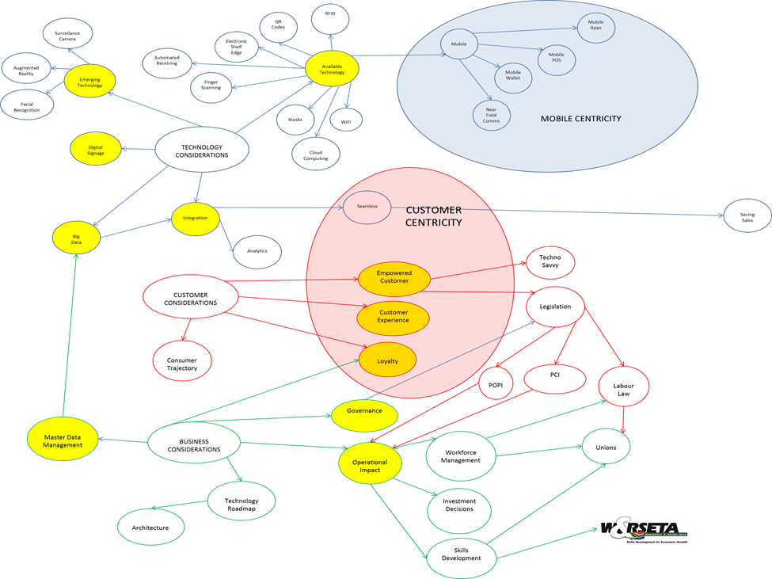

**ADDENDUM 2- Dave Rogerson**

**Research questions on Advanced Technologies.**

**1. How is the customer shopping experience improved since the introduction of advanced technology**?

There has been a positive impact on the shopping experience since the introduction of advanced technology. This however is dependent on the technical maturity of the retailer. It also depends on the strategic use of the technology. Technology for its own sake does nothing to enhance the relationship with the consumer. This only happens when the consumer is made to feel empowered by the technology. An example of this is allowing the consumer the opportunity to access information that will help them make a purchase decision, (i.e. product knowledge, the opinions of other consumers, inventory availability).

**2. What should leaders consider with regards to the introduction and deployment of technology in the organization?**

Retail executives should always implement technology with an eye to the future. It makes little sense to build a Smartphone app if the overall strategy for a multi-channel environment is undetermined. Without knowing how a technology will complement a long term architecture, it could well be a very short-sighted investment. Technology should also be implemented with the buy-in of associates. They are the ambassadors of your brand and will be asked questions about the technology by consumers. Without their support and involvement, any technology with a consumer implication will be put at risk.

**3. What Technology do you see changing the face of retailers in the near future and why?**

Mobile technology has the greatest implication on retailers. The purchase of tablets and smartphones already exceed those of PCs since 2010. They are the device that will enable retailers to engage consumers in a full multi-channel experience. They are also the device most likely to drive changes in marketing campaigns, types of currency accepted at the point of sale, and challenges in terms of data acquisition and integrity.

**4. How do you use technology to leverage your brand?**

Technology can be the greatest point of leverage to enable consumers to communicate about your brand, (for better or worse). At the same time, technology has empowered consumers to the point where they can exercise great control over the perception of your brand. The best way to engage consumers through technology is to provide the following;

* as a means to share their thoughts about your brand with like-minded people
* as a means to provide the retailer / brand with ideas (co-creation) and feedback

as a way to provide consumers with non-financial benefits in return for personal information (i.e. free offers, access to products before they are available to the public, tailored offers)

Provide consumers with a means to find the nearest store with the inventory they need in stock, (requires a connection to the inventory management system)

**5. Does the introduction of these advanced technology impact the labour force and if so what are the considerations when implementing such?**

There is an impact on associates, and if handled properly it can be a positive one. This can be addressed by using the technology to empower associates in the same way as you seek to empower the consumer;

Provide information that makes them more productive

Provide product knowledge content

In any event, there is always a potential for the associate to feel threatened by the technology. The best solution for this is through education and partnership. By removing the mystery of how the technology will be implemented and the inherent advantages, the associates will begin to embrace the technology as opposed to feeling like the change will threaten their employment.

**Dave Rogerson**

**ADDENDUM 3-RICHARD GARVIN**

**Research questions on advanced Technologies.**

1. **How is the customer shopping experience improved since the introduction of advanced technology?**

It’s questionable if the providers of new technology have yet perfected the usage and deployment of these new technologies? Perhaps we can break the topic down with “bite size” answers.

• LED Lighting: The cost threshold of this lighting as a replacement to traditional florescent and

incandescent lighting is becoming more and more attractive. This is a big win for retailer to save on

energy costs, labour and obtain better colour balanced lighting.

• Digital signage: Don’t go there unless you have content or resources dedicated to take marketing

materials and transfer, edit and repurpose the content. Many companies utilize outside specialists

who do this as a dedicated business.

• new wireless POS and inventory control is a huge success to keeping better track of product

distribution, sales and a deterrent to internal shrink.

• Security technology has seen significant enhancements

• Marketing materials & signage deployment to stores: In many instances head office information may

not be updated as to how many POS materials are required by individual stores. Huge amounts of

money is wasted sending too many pieces which are not used or over cluttering the store.

**2. What should Leaders consider with regards to the introduction and deployment of technology in the organization?**

• Does the retailer’s IT infrastructure have sufficient bandwidth, qualified people to operate and train

new staff.

• The human Resources Dept. should be an integral partner to support growth with trained, motivated

individuals.

• Does strategy require the acquisition of another company or contracting out this specialized work until

the subject matter expertise resides inside the retailers offices?

• Technology represents change. People are afraid or resistant to change, it’s a natural, universal issue.

It’s important the most senior company officers are seen as ambassadors of this change and promote

it top down. If this does not happen, the conversion will be fractured or be seen as unsupported.

• Customers require assistance and support to make any significant changes. How will this be

facilitated?

**3.What Technology do you see changing the face of retailers in the near future and why?**

• No. 1: The smart phone’s capability and availability of applications will open a new world of

information empowerment.

• No. 2: The tablet will become a wire sales tool for staff to be having information at their finger- tips. The

same technology provides “intelligent” self-service stations or mini kiosks anywhere in the store.

• No.3: Mobile technology and marketing, use of loyalty customer information will create larger data

bases so customer knows what their customers are buying or want. Targeted mass merchandising.

* No. 4: Demands on the retailers will become higher and consumers become more savvy and smarter.

“The Genie has been let out of the bottle!”

**4. How do you use technology to leverage your brand?**

• The internet has become the global network to connect, compare, market, inform and create

Communities who share a common interest.

• Communities become social marketing by virtue of the fact people want to share common interest,

goals, a place to be heard and gain identification.

**5. Does the introduction of these advanced technologies impact the labour force and if so what are the considerations when implementing such?**

• Yes. Knowledge workers will be affected first as our global society has moved from a world of manufacturing industries to a world of service providers and consumerism.

• What happens on another continent with its banking or economic conditions will affect people on the other side of the world. This could mean interest rates, jobs related to supply and demand, health and tourism.

• We have moved from a world where the large buy the small to a world where the fast eat the slow!

• Does the business sponsor “Career Fairs” it’s it HR practices?

• Does the business sponsor scholarships with post-secondary, college and universities?

• What pro-active actions does the business demonstrate they have a great company to work for? A place for career advancement and further education or better professional working environments?

• What environmental causes or charities does the business stand for? Does it stand for anything beyond selling goods and services?

• To be patriotic is not enough.

• Does the business seek out what is taking place in the global marketplace? What other best practices employed elsewhere can be adapted for your use. This often creates innovation which in turn creates market leadership. Leaders lead, others copy.

• Human beings are universal; they want to be part of a winning circle of life that nurtures

Success through good work and empathy & care for our global village.

**Richard Garvin Total Retail**

[Richard@garvintotalretal.com](mailto:Richard@garvintotalretal.com), Canada 416-729-2310

**ADDENDUM 4-Inez Blackburn**

**Research questions on advanced Technologies.**

**1. How is the customer shopping experience improved since the introduction of advanced technology?**

There is so much technology being deployed in store and at all points of contacts that shoppers are actually being overwhelmed. I think that you need to segment technology into two primary segments; One that is focused on store operations and efficiencies and the other on the customer experience and marketing initiatives. The challenge lies in understanding how the technology impacts the lives of the individual using the technology. I also believe that all technology should have a positive impact on the customer experience and companies should strive to have one view of the customer. I also see a complete integration of Bricks and Clicks as Retailers will evolve to offer full online capabilities in-store. Another area often overlooked in the deployment of technology is the integration of disparate technologies resulting in synergy and reciprocity with respect to the customer experience.

I do believe that the customer experience as improved as mobile technologies, predictive analytics and technological advances across the supply chain have reduced out of stocks and positively impacted the path to purchase. I do feel that technology for the sake of technology will not result in a significant benefit to the shopper unless we take the time to understand how the technology in question solves a problem better than the incumbent. With respect to mobile technologies and deployment, I believe that there is an upper limit as shoppers are being overwhelmed by the barrage of messages and targeted communications. We are really at the tipping point where relevance, convenience and ease of use will drive adoption

**2.What should Leaders consider with regards to the introduction and deployment of technology in the organization ?**

Many business processes have realized significant gains in productivity by effectively leveraging technology most often in areas that are extremely labour- or data-intensive or that require extensive analysis. The growing acceptance of the Internet and demand for instant gratification has raised the bar when it comes to consumer expectations for service and quality. Quality of life should improve significantly as the horizon of work and retail opportunities expand.

While there is still a long way to go on fully leveraging our technology, progress has been made in the following areas through increased collaboration:

Achieving competitive price points at retail—increased analysis and collaboration with respect to forecasting demand and what it takes to achieve desired price points

More effective promotions and features—analysis of promotion tactics, prices, volumes, and costs due to more timely feedback of what is working and what falls short

Increased local or store-level marketing—joint promotions targeting specific consumer groups or a geographic area

More effective shelf and space management—leveraging consumer insights more effectively

Product assortment and new product development—rationalizing SKUs to the most profitable and highest volumes for the distributor, significantly reducing the propensity for duplicate items

In addition, trading partners are increasingly sharing consumer insights and market research and hardwiring these insights into future decision making. Manufacturers are increasingly asking their retail partners for guidance regarding new product introductions and price points, and they are more likely to listen to advice regarding product sizes and assortments.

While progress has been made and efficiency has increased, in reality these gains have fallen short of expectations that out-of-stocks would become obsolete. One of the main reasons that successes have been limited is the lack of marketing information system capability and compatibility. Integration of databases is required for a buyer and seller to collaborate effectively, which in turn requires compatibility and consistent industry protocols. Many firms that have examined this in depth have determined that costs can be far greater than any measurable benefits. This is especially the case given the variety of systems, vendors, and consultants.

**3. What Technology do you see changing the face of retailers in the near future and why?**

I see the emergence and convergence of mobile technologies and Near Field Communications (NFC) changing the face of retail as well as the integration of the online and physical store. I also believed that emerging demographic segments will leverage social media tools and capabilities to improve productivity in-store through more effective communication.

The time is approaching when it may never be necessary for consumers to visit a retail store to purchase something. However, numerous research studies also indicate humans’ need for interaction and socialization, which makes it unlikely that traditional retail formats will ever be completely abandoned. We believe that retailing will migrate toward a physical retail presence complemented by a menu of added-value products and services such as a location for community groups, banking, healthcare, and education. Consumers will continue to become more demanding as their needs are being met with record speeds. Consumers will also reap the rewards of more efficient global supply chains as retailers continue to source products from around the world.

**4. How do you use technology to leverage your brand?**

Technology in isolation will not leverage a brand it can only be used to engage a shopper segment or strengthen the relationship through technology. We are committed to constantly improve the products and services we offer and are always looking for what’s new and what’s next. Any technology that we deploy must result in a stronger value proposition for our customers. Technology has however been used for marketing initiatives specifically social media to develop stronger relationships with their customers.

**5. Does the introduction of these advanced technologies impact the labour force and if so what are the considerations when implementing such?**

Technology must be designed and aligned around the customer experience and aligned with your corporate strategy and objective. It must be designed around principles of empowerment rather than control. Employees must be able to leverage the capabilities of technology to better serve their customers. The greatest strength of technology is the ability to convert data into knowledge, but the greatest benefits will emerge when you learn to share that knowledge in an environment of collaboration. Historically technology has been used to monitor and control behaviours; now it must be used to inspire and empower behaviours.

**ADDENDUM 5**- Jennifer Lee

Hi Ashley,

Great to meet you at the session. Attached are my thoughts to your questions:

1. How is the customer shopping experience improved/enhanced since the introduction of advanced technology ?

- The customer now has more information that the sales associate in the store. Customers are able to use mobile technology to price check, share their experiences real time (ie. trying on a new dress and showing her friends) and also easily find store locations, as an example.

 2. What should Leaders be considering when it comes to introduction and deployment of technology in the organization ?

- ensure that the technology chosen and technology partners ties into the path to purchase. If it doesn’t then you run the risk of spending a lot of money for a technology that may not enhance the customer experience.

 3. What Technology do you see changing the face of retailers in the near future and why?

- price checking is going to disrupt the retail market because it will now force retailers to have to compete on more than just price.

 4.How do you use technology to leverage your brand?

-ensure the technology experience is integrated. Nothing hurts your brand more than a disjointed and inconsistent experience.

 5. Does the introduction of these advanced technologies impact the labour force and if so what are the considerations when implementing such?

- I believe the type of labour that you hire now will require a different skill set. They will need to be able to use these technologies and be agile as the organization introduces new applications and hardware to serve the customer. Change management is going to be an enormous issue.

 Hope this helps.Jen

**ADDENDUM 6**-OVERVIEW OF GLOBAL ENABLERS OF MOBILE MARKET



**ADDENDUM 7-STARBUCKS EXAMPLE**

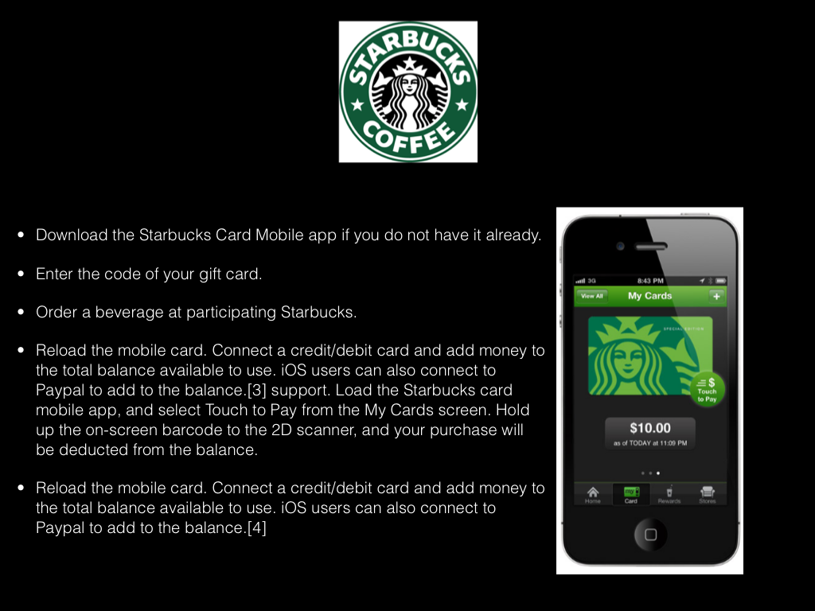

**ADDENDUM 8- Augmented Reality Image**



This Application " The World’s first image - recognition phone app aimed at bringing to life real- world newspapers, magazines, products and posters with exciting AUGMENTED reality experiences and instantaneous content."



Most Retailers in the Immersion have also embarked on placing WIFI capabilities into the stores to not only tap into the consumer by making it possible to interact but also to enable them to map their customers and their path to purchase, thus enabling better planning in store layouts.

**ADDENDUM 9 :**

**Research questions on advanced Technologies.**

**SURVEY 1**

|  |  |
| --- | --- |
| **QUESTIONS** | ***Greg Allen: Responses from Network Perspective*** |
| 1.How is the customer shopping experience improved/enhanced since the introduction of advanced technology? | Backend Network enables new technology in stores. Coffee shop Internet Access and introduction of POC Coffee shop wireless Pin Pads for Payments. Walkie Talkie Type Communication within store, Wi-Fi Guest Technology within the Woolworths Campus is Technology Voice and Data have introduced. |
| 2.What should Leaders be considering when it comes to introduction and deployment of technology in the organization ? | How it will enable there workers and offer better services and enhance the shopping experience for customers. It must be simple |
| 3.What Technology do you see changing the face of retailers in the near future and why? | Wi-Fi – Can Track shoppers and empower them online to make choices. Most people have a powerful computer in their hands a smart phone. |
| 4.How do you use technology to leverage your brand? | Make the customer Experience easier. Internet in Coffee shops – Wi-Fi Pin pads to enable customers to pay at tables. |
| 5. Does the introduction of these advanced technology impact the labour force and if so what are the considerations when implementing such? | Any technology Impacts the Labour force, The Walkie Talkie Type Communication gives a store manager constant online contact with key individuals on the floor to react. |
| 6.In terms of the deployment of advanced technology in your retail environment, what would you say is the approximate budgeted percentage spend relative to the total budget | Can’t Say but in IT very small. |
| 7.With regards to implementing advanced technology in a retail environment, have you seen any benefit and if so what kind of benefit was realized? | With the ones we have been involved with in last 6 to 12 Months, from usage I would have to say YES |
| 8.Is there a rate of return that can be measured by your company to calculate the cost vs benefit effect of implementation of this technology and if so , what has it been in the last 3 years? | In Voice and Data we can measure by stats amount of Data and amount of users using the technology |
| 9.With the rate of technology change increasing, how quick does your organisation generally adopt and implement new technology? | Sometimes First Few to deploy, mostly followers of proven technology |
| 10.What kind of advanced in store technologies are you currently viewing as a must have for retailers? | Larger Bandwidth to stores. Wi-Fi Coverage to enable future technologies |
| 11.Would you say that it is important for retailers to be early adopters of technology? Please expand on your opinion. | Yes, It can give you an advantage as the customer can purchase anywhere today. You need to GRAB them while they are in your store and WOW them and make experience GREAT to get them to buy then and there. They are not dumb to Google an Item or Price Check it somewhere else. |

**SURVEY 2**

|  |  |
| --- | --- |
| QUESTIONS | Shaffique Akoonjee: Response from Trade port Distribution (Pty) Ltd |
| 1.How is the customer shopping experience improved/enhanced since the introduction of advanced technology? | Being small to medium sized scanning and on-line transactions have become synonymous making transactions faster and easier. |
| 2. What should Leaders be considering when it comes to introduction and deployment of technology in the organization? | Security and control measures are needed to be implemented in terms of access and risk management and skills development for the entity while upholding high standards of quality. |
| 3. What Technology do you see changing the face of retailers in the near future and why? | Apps and big data as well as large scale on-line transactions |
| 4. How do you use technology to leverage your brand? | Web based and cellular advertising, |
| 5. Does the introduction of these advanced technology impact the labour force and if so what are the considerations when implementing such? | Big impact due to large skills shortage and lack of knowledge on implementing technology. Reduction of labour intensive workforce prevalent in the industry |
| 6.In terms of the deployment of advanced technology in your retail environment, what would you say is the approximate budgeted percentage spend relative to the total budget | Due to being a small to medium term scale entity at least 30% increase annually due to implementation of new technology should decrease to 10-15 % as technology infrastructure is established |
| 7.With regards to implementing advanced technology in a retail environment, have you seen any benefit and if so what kind of benefit was realized? | Services are quicker faster more efficient. Productivity increased due to implementation of new technologies thus enhancing processes |
| 8. Is there a rate of return that can be measured by your company to calculate the cost vs benefit effect of implementation of this technology and if so, what has it been in the last 3 years? | Cost is difficult to measure but the benefit is displayed in productivity which is difficult to ascertain in rand terms. |
| 9.With the rate of technology change increasing, how quick does your organisation generally adopt and implement new technology? | In recent years almost annual update of software hardware and new innovations if adoption is not immediate it can result in major losses |
| 10. What kind of advanced in store technologies are you currently viewing as a must have for retailers? | e-wallet, Wi-Fi technology in store and cellular technology and on-line shopping |
| 11.Would you say that it is important for retailers to be early adopters of technology? Please expand on your opinion. | It is an imperative measure to make the entity stand at the forefront of the fast paced evolving global environment |

**SURVEY 3**

|  |  |
| --- | --- |
| QUESTIONS |  |
| 1. How is the customer shopping experience improved/enhanced since the introduction of advanced technology? | All the information customers require to make buying decisions is available online. This means they are either using mobile devices to make decisions in the shop or they are doing their research beforehand. Customers are now empowered to make decisions on the fly. Should I buy this here? Is it cheaper at store X? Is there another store X in this mall so I can go have a look? They can do this from their handsets. With regards to doing research beforehand. When last did you buy a TV without researching first? You don’t rely solely on the store staff to inform you any longer. You research beforehand and go into the store with a fair amount of knowledge. All the information at the customer’s fingertips means the store staff need to know their stuff and can’t make mistakes. |
| 2. What should Leaders be considering when it comes to introduction and deployment of technology in the organization? |  |
| 3. What Technology do you see changing the face of retailers in the near future and why? | Online is an obvious one. Mobility another – both enterprise mobility and mobility for customers. I touched on why above |
| 4. How do you use technology to leverage your brand? | Technology allows you to appear to be a modern company with your customers’ needs at heart. It’s got to be bullet proof though. A poor use of tech can be brand damaging. Look at the kiosks in the Waterfront. Great idea. Great content. Useless touch screens that are frustrating to use |
| 5. Does the introduction of these advanced technologies impact the labour force and if so what are the considerations when implementing such? | buildingEmployees need to be more technically savvy to keep up with the tools that will be made at their disposal. We are going to have to come up with better ways of training and up skilling users to handle the newest technologies |
| 6.In terms of the deployment of advanced technology in your retail environment, what would you say is the approximate budgeted percentage spend relative to the total budget | Can’t comment but it’s low. The majority of our spend is C&R. |
| 7. With regards to implementing advanced technology in a retail environment, have you seen any benefit and if so what kind of benefit was realized? | I don’t think we have done enough to be able to measure. |
| 8.Is there a rate of return that can be measured by your company to calculate the cost vs benefit effect of implementation of this technology and if so , what has it been in the last 3 years? |  |
| 9. With the rate of technology change increasing, how quick does your organisation generally adopt and implement new technology? | Not very quickly. Retailers are generally more conservative and wait to see what catches on before spending money on things. |
| 10.What kind of advanced in store technologies are you currently viewing as a must have for retailers? | You can’t ignore mobile any longer – particularly enterprise mobility. Getting relevant up to date information (of all types) into employee’s hands is critical. |
| 11.Would you say that it is important for retailers to be early adopters of technology? Please expand on your opinion. | No. Technology has lots of fads that come in as the next big thing and then fade off into nowhere not long after. Retailers need to watch their spending and thus need to bet on the biggest wins which means you aren’t going to be taking gambles on green technology and will rather go for the settled ones which are usually by then in a state where there is critical mass and thus more cost effective. There is enough scope to choose from – meaning there is enough business opportunity and enough settled technology to keep WW busy for some time |

**ADDENDUM 10: BUSINESS PLAN**

1/01/2013

**EXECUTIVE SUMMARY**

**COMPANY BACKGROUND**

A large Wholesaler and retailer of household goods.

**DESCRIPTION**

It’s an electronic system that talks pricing back to a central unit which controls all pricing elements of a product on a shelf. By virtue of level of security an individual will be able to call up to a digital screen on the shelf all pricing, costing and selling price history related to any product at floor level at any given time.

**BUSINESS IDEA AND UNIQUE POINT**

Our business plan is to implement electronic shelf talkers in our distribution centre.

**IMPLEMENTATION PLAN**

Align the in house program to enable it to integrate with the shelf talkers’ software and develop the in house communication with external software packages available.

**DEVELOPMENT OPPORTUNITY**

To develop and increase the automation of the stock system and to improve communication links between pricing and buying.

**FINANCIAL PLAN**

Initial capital requirement for software is R 1 million.Initial capital requirement for integration and personnel is approximately R400 000.

**IMPLEMENTATION PLAN**

Currently we are four members of the team,:

Zaheer Joosab - Team Leader, Balan Moodley - Developer, Adderley Chinniah - IT Mike Ross - Stock Control Manager.

**RETURNS ON INVESTMENTS**

Return on investments will be difficult to measure. It will be based on improvements in human resource capacity.

**SWOT ANALYSIS**

|  |  |
| --- | --- |
| **STRENGTHS** | **WEAKNESS** |
| 1. Improve stock control | 1. Costing verses benefit |
| 2. Less labour intensive | 2. Lack of technical experience to run system |
| 3. Reduction of time |  |
| **OPPORTUNITES** | **THREATS** |
| 1. Opportunity for better integration with other software | 1. Staff issues |
|  |  |

**FINANCIAL BREAKDOWN**

Cost of software R 600 000.00

Cost of labour R 150 000.00

Cost of integration R 100 000.00

Cost of hardware R 50 000.00

Cost of internal integration to in house system R 125 000.00

Cost of labour – additional lead time R 150 000.00

Cost of stationery, label, printing ect R 50 000.00

Other cost – unidentified R 75 000.00

Total R1 400 000.00

BUSINESS STRATEGY:

The action learning program was actually the first source that gave root to the concept of introducing advance technology within smaller working environments. This blueprint is in effect the first draft to obtain board approval to be effective in improving technology in smaller retailers within South Africa.

The business strategy proposes to use electronic shelf talkers to further automate the business. In terms of strategy, this process will improve integrations between receiving, stock management and distribution. It will lead to effective communication from source to floor and floor to source.

PROPOSED SOLUTION:

The proposed plan would enable the entity to begin its plan to become competitive within a constantly changing technological environment. The company is aware that changes to keep abreast are fundamentally important in order to become leaders within the retail sector.

WHAT DOES THE SOFTWARE DO?

The software enables an individual on the floor to scan information on a product immediately from a barcode. People would suggest that barcode technology is an established method. This will enable the barcode reader to have every detail current or historical on the product and be able to forward it, save the data and manipulate it for reporting purposes.

PROPOSED BENEFITS

We know we will not see the benefits in terms of investment but we will see the return to be measured in terms of staff productivity rates, task completion measurement and overall return on productivity.

WHAT IS THE COST?

The costing has been outlined as per annexure 9. The company is measuring the rate of return that it would gain from implementing the new system. In our measurement we have undertaken to investigate within the last twelve months the cost of labour utilized and the time and cost saving in comparison to implementation benefits.

CONCLUSION

The board of Directors will finalize at the next general meeting the approval of the business plan. A request has been sent out. Further breakdown will follow in project management phase.

**Addendum 11**

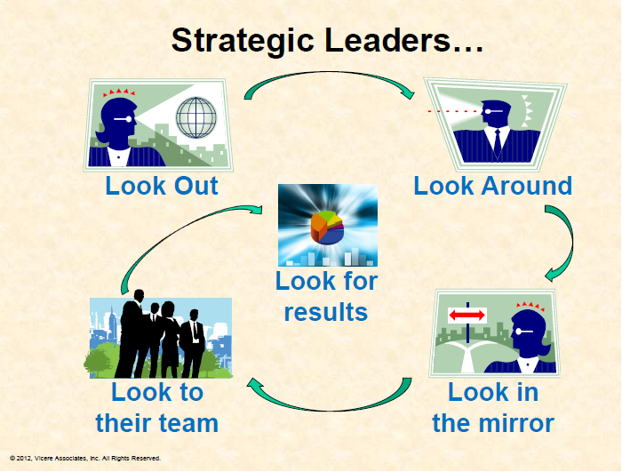

**Group Learning’s on ALP Process**

**Marlon Govender**

As we were put into our groups early on in the programme I was rather apprehensive, this was due mainly to the fact that I was far more comfortable working alone and generally avoided group interaction if possible. Most of the exposure that I had had over the years was the one where I was the leader of the group and ultimately was the decision maker. So the first hurdle was to becoming comfortable with the fact that I would now have to work closely with relative strangers and more so that fact that we were all equals. This process was really made so much easier by the group interaction that was encouraged early on. Having intimate discussions and sharing personal information about ourselves in the group environment made it so much easier to deal with the group as we quickly became friends and started to trust each other more easily.

The next hurdle was to start breaking down stereotypes and assumptions. At first the tendency was that I had all the answers and that I was always correct and that led to me not always affording the others the proper consideration that was due. It was only a short matter of time before the harsh reality came crashing in that I did not know everything and that in fact I had so much to learn. The various assessments that we were subjected to played a vital role in helping to deal with this. (Belbin / Personality profiles / team roles / left brain right bran) This was followed by the nuts and bolts of our project, the hard work, and the complexities of researching our topic. We went into a prolific time of divergence and simply found tons of information on retail advanced technologies.

It was so difficult to be excited about the topic at first, as there was lack of clarity on which of the technologies we were going to focus on, there was just too many. Here again, with proper coaching we realised we had to focus on the customer more than the technology.

The international retail immersion did 2 things effectively; firstly it firmly cemented our team into a more cohesive, efficient team simply through a baptism of fire. Secondly, it brought to life our ALP research topic and made all of us really excited about it. SO armed with a wealth of theoretical and practical knowledge we touched down in SA ready to tackle the local part of the project. For obvious reasons the group’s energy levels dropped drastically after the trip and it took some persuasive cajoling of the group leader to get things jump started again. Probably the most difficult part of the project for us was the divergence stage and the cutting down of information. We really worked hard and delivered a satisfactory 80% stage of the project. The last 20% has been rather challenging and the team have been struggling to put to bed a conclusive business proposal based on our research. I am certain that with the usual explosion of joint effort we will land that before the final submission.

The exhilarating journey our syndicate went through has seen us transform from strangers to colleagues to lifelong friends! It has challenged us to the very core of our beings and tested our agility and resilience in every aspect. We are proud to have come out better people and leaders through this process and look forward to a bright future for each team member of our incredible syndicate, Inzula Lwazi!

**Christopher Brikkels**

The approach to action learning has always delivered significant personal lessons which I inevitably include into a maturing managing practice. It is not the first time I have been exposed to this type of learning but it has always delivered successful personal outcomes. This case is no different.

A couple of things for me have re-surfaced and have reminded me how important one has to consistently revisit one’s management framework. These are

• Remain positive when things get tough

• Be aware of how you interact with others as your own behaviour has an impact on the group (listen to understand rather than respond).

• Try and create the intelligent workspace for the group to operate well in

The initial framing of the ALP created the research approach to how I group was going to tackle the problem. Once again this was a great process to go through provided me with a platform that I can use to tackle any kind of complex problem. It was about creating the context, defining key concepts and asking the relevant questions that we needed answers to. By following this process our objectives soon became visible and apparent.

The actual journey of seeking answers to the questions we had was also an interesting one. In my own space, I chased these with vigour, but constantly reminding myself but to lose sight of the learning opportunity. The insights gained around customer needs versus technology solutions became more apparent. It was here that the preverbal penny dropped for me. When one frames a problem or a research study, one often thinks that we have a view of what the desired outcome should be. I work in the IT department for Woolworths and what I now deem the “chase for new technologies” was foremost on my mind when I was conducting the research with my team. Our research was actually mostly about the customer experience and the technology solutions the enabler to meeting the customer needs. The linkages were clear and our exposure to Ricardo Machado’s lectures around the principles of marketing and the customer experience validated my own thinking as well as that of the group. We just needed to structure our recommendations appropriately so that the ultimate message was clear.

I have realised that the rate of change outside the organisation is fast and if organisations don’t adapt they will not survive, especially in a world that is globally connected. The same can be said of me in the context of the organisation as well as my personal life. This ALP and the ILDP course reminded me that one should never stop learning. Being relevant comes from the fact that we strive to educate ourselves, make the best of our opportunities and engage our fellow human being with the respect they deserve. As a leader I am an effector of change. Having this understanding in conjunction with my recent exposure to the global context, I have to be prepared to change systems (in whichever form) for the positive. This ALP has reminded me about the value of reflection. I was reminded of the fact that my thinking becomes my behaviour. If you had to ask me what my biggest lesson was, I would say trust. I had to let go and let the team get on with what they needed to. What a journey it has been. I feel blessed for have been given the opportunity to be a part of this course.

**Ashley Volmink**

The journey was an extremely insightful, demanding yet exhilarating experience for me. Initially the thought of embarking on this journey made me have feelings of uncertainty in what I was going to take out and implement at the workplace and in South Africa Retail. Meeting so many leaders in the industry and opposition was daunting but through time I have fully learnt and understood the complexities and the common goal that we share in attaining a sustainable future in South Africa's Retail Sector.

The various lectures and plenary sessions that I was exposed to we're absolutely world class, insightful and thoroughly enjoyed. Some key insights from some of the speakers

**Adrian Saville**- Context is critical.

**Professor Karl Hofmeyer**- Strategic Leadership and Personal Mastery, if you carry on doing the same things you will miss opportunities and vision influences our perception which in turn controls our reality.

**Martin Butler**- “If it ain't broke ....BREAK IT!"

**Colleen Magner**- Scenario Planning- look at all aspects and when faced with a dilemma, one needs to scenario play possibilities and outcomes.

**Nicola Tyler**- Innovative and creative thinking- “Everything in life is a choice. If you have no choices you're a victim, but if you have options it opens your world to endless possibilities. You can make impactful decisions and put into action".

These are only some of the speakers/lecturers but I truly found myself interrogating my own ideals and the way I approached various challenges. Learning to work with people and really listening, understanding their viewpoint’s has better equipped me in solving issues much easier in the workplace. My full-hearted embracement of understanding the context has rounded me in tackling complex issues and I definitely will endeavour in reaching out to better up-skilling myself but more importantly others in this quest to provide stability in the sector and in my private life. I definitely have really enjoyed this precious time with my Group on our journey and through these integral networks am able to leverage ideas and discussions to problem solving within this. Working in the Syndicate taught me to respect views and being “Blue” the patience and acceptance to accept and embrace views and opinions without prejudice.

A huge thank you to the W&RSETA and GIBS for making this possible.

**Gloria Mthethwa**

Vince Lombardi once said, “Individual commitment to a group effort - that is what makes a team work, a company work, a society work, a civilization work”, a motto I have come to live by and adhere to in order for me call myself a team member and a good leader

Without a doubt, the Action Learning Project has been a great learning curve for me as it got me reviewing, and doing an introspection on a number of things, such as:-

• Leadership/Personal Mastery

• Discipline and perseverance

• Communication and team dynamics

I have discovered my true potential in terms of being a leader, I believe that to be an excellent leader you need to be able to lead yourself, which is a skill I have come to appreciate and embrace. This leadership trait is achievable if you are able to stick to your plans, remain committed and always lead by example in everything you do.

The Action Learning Project also offered me an opportunity to learn from other team members, and I also learned what it means to be a good communicator, particularly communicating and have you heard within a group. A few great learning’s that came out of the Action Learning Project are:

• Listening with an intention to understand and allowing others to put forth their views

• Being respectful and sensitive to other people’s feelings

• Allowing one to learn from other people

• Being a team player, reliable and honest

From time to time I had to take a step back and review how I was performing in terms of the above in order to to better myself and put into practice what I’ve been taught.

The topic on technology within the retail sector has been exciting and got me immersed and interested on how technology could add value in the retail sector and how South African retailers and their customers could benefit by fully embracing it.

I have learned that anything is possible, as long as one has the discipline and perseverance to achieve their goals. Whatever I embark on – I need to keep pressing on, be disciplined and never give up. More than ever before, I allow myself an opportunity to learn from other people. What I know for sure is that I have learned immensely from my team and Bonita’s coaching – for that I am truly thankful.

**Lucky Mandlazi**

At first this was very scary and intimidating with high expectations from my company especially my line manager, and the thought that I will be among other 36 shinning and powerful talents made me to think that maybe I was not good enough but very grateful at the same time. I have landed in a very tough way than others in that in my first encounter I had to deal with a very strong personality and deal with it openly and taught me that I needed to be more resilient and tougher than I am.

As a Human Resources leader I appreciated the importance of value chain and need to collaborate even more to improve services. I understood much better that people dynamics are very important to understand and manage daily using situational leadership. The biggest learning ever was to understand the need to deal with issues quicker and move on, be prepared to take tough decisions.

I now have better understanding of my personality through the assessment and have learned that my true and original personality probably is the best. I am always conscious of my actions and I would rather not talk than to talk and be wrong and the ALP process have encouraged me to test my opinion from time to time without any fear of failure.

I take away high level of excellence that I have learned from all stake holders, discipline, respect for others and surviving high level of pressure, self-confidence, bravery and importantly the need to understand context and spend time trying to understand the problem and less to fix it. I felt out of place in my team at first due to different personalities but with the powerful coaching and interventions by professionals I am now able to relate to any personality very comfortable and all thanks to W&R SETA and GIBS.

This program rose more appetite for me to further my studies and do my MBA with greater focus in Retail and leadership, further I am now more curious to understand the changing patterns of customers and I fell more in charge in my space than I was before. Many thanks to the leadership of W&R SETA, GIBS and my colleagues for the wonderful journey we had, I will always look around, look out, look in the mirror, look to my team and look for results.

**Zaheera Joosab**

This was my first experience in interacting on various levels with different individuals with the purpose of a learning output that would actually be used for the future of developing our country. It's been an experience that has exposed so many facets of learning, and immeasurable improvements within my capacity to manage.

Firstly, the exposure to an international audience and experience and the vast leaps that mankind is making in developing the world in every sphere of retail was awe inspiring to watch. I learnt the value of what we extract in terms of research material as well as the ability to culminate our findings into the written word.

The team effort and communication has been phenomenal. Initially, I was awe struck being from the little independent but I soon realized that each individual had a sphere of strength that contributed its own unique facet to this action learning project. The flow of ideas the sparring into agreements and disagreements helped us appreciate the value of every contribution into the unified product we created.

Specific lessons which I have drawn from the ALP were:

1) The value of a variant of dynamics within a team

2) The strength of management skill in monitoring and accepting responsibility to deliver.

3) The value of good communication.

4) The ability to understand how research should be used in the analysis of a solution.

5) The practical application of many studies provided to us during our courses guided us in moving towards the ultimate solution.

6) The value of coaching in not deviating from the proposed solution.

7) The findings, the investigations, the questionnaires to ultimately understand the problem statement via so many different perspectives.

8) The combined skills from different spheres of expertise makes one realize what a combined contribution and the value it adds when brought together.

The greatest benefit to me as an individual is that I learned diversified innovation thinking.

I gained insight into my weaknesses and strengths. I learned to be a better listener whereas in the past I contributed more and listened less.

It has made me appreciate the value of teamwork and how a positive, motivated group can build any bridge and achieve great success if the combined input is used to it effective best. I will always look back at my team and be grateful for the manner in which each of them has developed me.Within this context, I believe I have been equipped with a knowledge and skill that I can take forward in assisting to build others and to assist in making pioneers that would grow and succeed our retail sector.