What can SA Retailers learn from India and China in capturing opportunities that present themselves at the bottom of the pyramid?

AFRICAN INNOVATIVE RETAILERS:
SYNDICATE 2

[Type the document subtitle] | GUERILLA WARFARE

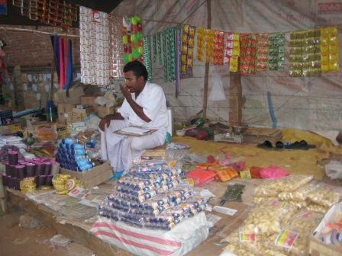
CONTENTS

Executive Summary Page 3-4

Introduction Page 5-8

Opportunity Statement Page 8

Importance of dealing with the BOP Page 8-9

Objectives and scope of project Page 10

Research Methodology Page 11

Results and Discussions Page 12-22

South Africa research and Discussions Page 23-25

Conclusion Page 26-27

Appendix Page 28-32

EXECUTIVE SUMMARY
“The Committee found that the current social assistance programme reduced the poverty gap by 23%. In the absence of the grants 58% of South African households would fall below the subsistence level of R401 per adult equivalent per month. However, the Committee also found that 50% (11.8 million people) living in the bottom two quintiles (some 23.8 million poor people) lived in households that received no social assistance.”

South Africa is living with the harsh reality of an unemployment rate of 25%, reliance on Government Social Grants that is escalating and a lack of job creation.

When we asked ourselves:”What can SA Retailers learn from China and India in capturing opportunities that present themselves at the bottom of the pyramid?”,little did we know of the journey that we would be embarking on.

OVERVIEW

Our research took us into China, India and South Africa, revealing positive and negative aspects of the BOP market.

China is progressively working towards reducing unemployment through its many Government initiatives and a growing economy. The Government has plans in place to create 300m jobs over the next 10 years. Massive growth is evident everywhere in Beijing and Shanghai, with new skyscrapers being built on a monthly basis. Companies that we visited used advanced technology in their daily operations and the staff was giving 110% to the task at hand.However, the lack of Labour Laws and any regard of Employee Rights was very noticeable. Through internet research, we found out that the BOP community lived in rural China, an estimated 500m people, and are mainly subsistence farmers with little or no access to electricity or piped water. Retailers however, are actively trying to attract the BOP market by offering goods and services that appeal to them, especially in the supermarkets.

India showed us the spirit of Entrepreneurship, with people who are willing to try and make a living by any means possible. The whole country was a microcosm of small businesses eking out a living. People are hard working, poverty is rife but it is possible to run a successful business in India.
India’s Foreign Policies allowing outsiders to trade in their Country may seem harsh at first, until we look at the deeper picture.”Kirana” stores throughout India provide jobs to millions of shopkeepers, in turn to millions of families. The local consumer trusts the local shopkeeper, to the extent that generations of families will continue supporting the local stores.
A foreign company coming into India has to adhere to strict criteria, including partnering with local businesses and sourcing local products. This is meant to strengthen local business while creating jobs, with a population of over a Billion people, this is of utmost importance to the local Government .However, corruption is a serious problem in India and this is undermining efforts to create stability in the country.
There is no doubt in our minds that South African Retailers are trying to capture the market at the bottom of the pyramid and there are plenty of examples to illustrate this fact. Right at the outset, we had to consider what makes a product attractive to the BOP market and we followed the following guidelines:

- Acceptability- The BOP consumer is extremely poor and businesses have to win his trust to capture this part of the market.
- Accessibility- The product must be easy for him to access.
- Affordability- The price must be right
- Awareness- Marketing must be uniquely targeted to the BOP market, eg. LG sells televisions from the back of a van in rural India.

This linked with the 4P`s marketing principals left us to explore whether we have done sufficient or can we learn more about capturing the BOP market from China and India, who has the highest market segmentation.

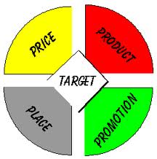

- Introduction
Can Business reap profits, eradicate poverty and solve environmental problems by turning the poor into consumers?

What is the Base of the Pyramid?

“The Base of the Pyramid (also referred to as the Bottom of the Pyramid) refers to the estimated 4 billion people around the world, who are poor by any measure and have limited or no access to essential products and services such as energy, clean water, and communications. Globally, people in this socioeconomic group earn US$1 to US$3 in purchasing power parity (PPP) per day. Yet these households often pay higher prices than wealthier consumers do for lower-quality goods and services because of uncompetitive markets.”

How do you define the BOP community in South Africa and what makes them unique from the rest of the World?
Statistics SA defines a person who lives on less than R1 290 PM as poverty-stricken. Another factor to take into consideration is that the SA BOP community lives in rural areas, as well as cities. We therefore have to consider people living on:
- Old Age Grants
- Disability Grants
- Child Grants
- Unemployment Grants
Official statistics put this figure at 16 million people, a third of the population of South Africa.

In the article “Fortune at the Bottom of the Pyramid” , the authors described four tiers that constitute the world economic pyramid. The top tier represents affluent, middle and upper-income individuals residing in developed countries and the rich elite residents in the developing world. The next two tiers include the poorer consumers in developed countries and the large middle-class in developing countries. Tier 4 represents the BOP consumers.
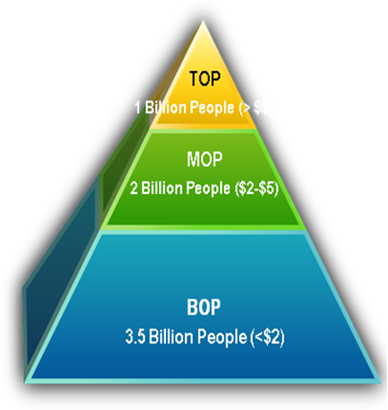

Political, social, economic and technological unpredictability in rural BOP markets has discouraged manufacturers and producers to actively participate in the operating environment. Variables in the operating environment that have adversely affected the interests of rural BOP end customers include the following:

Infrastructure Constraints: Low penetration of civic and private infrastructure in rural markets such as roads, water channels, electricity and telecommunications, has created barriers to entry for affordable mainstream products. It has added to the financial burden on manufacturers and producers of product redesign, manufacturing facilities, physical distribution, and operations and maintenance that are more suited to local infrastructure availability. Lack of adequate infrastructure in rural areas has shifted producer/distributer attention away from the basic underlying needs of the end customer. Absence of modern technological interventions, mass media instruments and platforms (coupled with excessive reliance on social media and opinion leaders) contributes to the information asymmetry that prevents the growth of effective rural
markets.

Geographical Challenges: Extreme weather conditions, long distances (geographical spread), and hostile terrain present unique transportation and storage requirements, which require a high degree of customization, both in planning and in execution of product distribution to rural BOP markets.

Non-homogenous stakeholders: Lack of homogeneity among key stakeholders in BOP market play, such as commercial players, civil society organizations, government institutions, and uncertain power centres (political, economic and social) across local communities demand sustained local insight by distributors, manufacturers and producers.”

The vast majority of those in Tier 4 live in rural villages and urban slums and shantytowns. The base of the pyramid markets are often rural, underserved, and dominated by the informal economy and as a result are relatively inefficient and uncompetitive. This market is often unorganized, local and limited in quantity and quality of products and services available. As greater numbers of formal firms compete to redress the BOP penalty, the poor experience a direct increase in quality of life.

Purchasing Power of India/China /South Africa v Population Size

Population in millions
Purchasing power  (US dollars, per year) | CHINA  Source 1 | INDIA  Source 1 | SA  Source 3
$20,000+ | 2 m | 7m | 1m
$10,000 to 20,000 | 60m | 63m | 3.5m
$ 5, 000 to $ 10,000 | 330m | 125m | 3m
Less than $5,000 | 800m | 700m | 24m

Markets traditionally addressed by consumer products

Underserved markets

According to the World Research Institute, markets can be broken up into “Red Oceans” and “Blue Oceans”. Red oceans are the traditional markets (Tier 1/2/3) and are highly competitive and companies have to take market share from their competitors (hence the name comes from blood in the water).
Blue Oceans represent the unknown market space (Tier 4) where there is no competition, therefore a business creates its own demand.

BOP markets have been historically neglected by multi-national companies, who have traditionally targeted the upper consumer segments in emerging markets. However, low-income consumers represent enormous volume and profit-potential for several sectors, starting with those serving basic needs such as food, hygiene and other daily consumer products. Furthermore, the most important aspect of this consumer segment is not their consumption potential today, but the shift into becoming a lower middle-class with higher spending power that will introduce them – in a 10 year horizon - into the global market as new consumers demanding global brands, products and services.
The informal market constitutes a significant business investment opportunity, one that a wise investor would do well to recognise. Opportunities in the informal sector rapidly translate into new business models that work for everyone. These investments act to lift the poor out of poverty, by reducing costs and increasing efficiency, resulting in saving the poor time and allowing their money to go further. With greater savings they can invest in their own well-being.

- Opportunity Statement
What can SA retailers learn from India and China in capturing opportunities that present themselves in the bottom of the pyramid?

“The real source of market promise is not the wealthy few in the developing world, or even the emerging middle –income consumers: it is the billions of aspiring poor who are joining the market economy for the first time.”

- Importance of dealing with the BOP
The advantages of dealing with the BOP:

- Sheer size of the population-lower profit but more units sold
- Rapid growth
- Less competitive environment
- Opportunities for cost saving
- Opportunities for innovation

Prahalad & Stuart further stated the following assumptions which in reality are the challenges within the SA retail sector:

- Assumption 1: the poor are not our target consumers because with our current cost structures, we cannot profitably compete for that market.
- Assumption 2: the poor cannot afford and have no use for the products and services sold in developed markets
- Assumption 3: only developed markets appreciate and will pay for new technology.
- Assumption 4: the bottom of the pyramid is not important to the long term viability of our business.
- Assumption 5: Managers are not excited by business challenges that have a humanitarian dimension.
- Assumption 6: Intellectual excitement is in developed markets. It is hard to find talented managers who want to work at the bottom of the pyramid.

- Objectives and Scope of project
BUSINESS CASE:

“Companies need to re-shape business models to include the Bottom of the Pyramid Consumer “

IMPLEMENTATION PLAN

With this in mind, our model to approach those markets is based on four key elements:

- Value proposition
- Business model,
- Distribution networks
- Local community involvement.

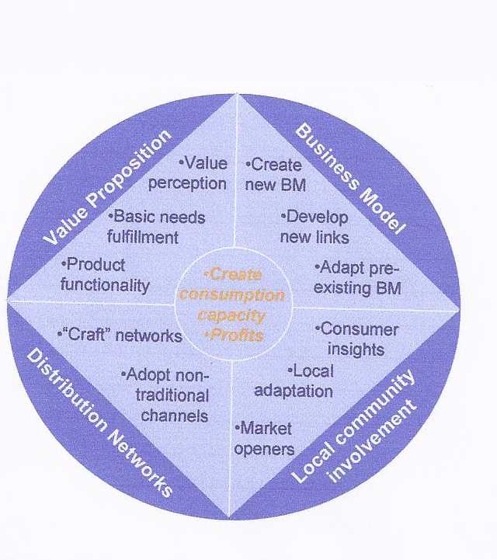

- Research Methodology

Source | Description
1 | C.K. Prahalad&K. Lieberthal, “The end of Corporate Imperialism”, Harvard Business Review, Aug.2003
2 | PERSONAL INCOME ESTIMATES FOR SOUTH AFRICA, 2010  (Research Report no 396) was compiled by Prof CJ van Aardt (Director, Income and Expenditure Research Division) and Mrs M Coetzee (Senior Computer Scientist) of the Bureau of Market Research
3 | C.K. Prahalad & Stuart L. Hart, “The fortune at the Bottom of the Pyramid,” Strategy + Business issue 26, first quarter 2002
4 | Bill Vorley (IIED)Mark Lundy (CIAT)  James MacGregor(IIED),Business models that are inclusive of  small farmer, Global Agro-Industries Forum, New Delhi, April 2008
5 | World Resources institute
6 | Wikipedia
7 | Centre for sustainable Enterprise
8 | IFMR research
9 | Source: Hu and Xia (2007)
10 | Sachin Shukla ,Sreyamsa Bairiganjan, The Base of Pyramid distribution challenge

- Results and Discussions
CHINA/INDIA IMMERSION

An Innovative Value Proposition

Further to adapting foreign products or value propositions, companies that have remarkably succeeded in these markets are those able to develop completely new value propositions, because instead of adapting a product or service that was designed with a western consumer in mind, they started by looking at the local consumers, their habits, preferences, needs and way of living, to then develop products or services that fit that unique consumer portrait.

All products for the BOP market need to be designed from the ground up with input and support from the local community .In Asia and Africa, the BOP community does not trust easily. Trust has to be earned and this takes time. Locals tend to stick together and support from local headsmen and community leaders will go a long way in assisting MNC’s in being successful in their endeavours.

It is a myth that price is the single most important criteria in choosing which products to buy. Consumers in these markets do not always opt for the cheapest offering. Functionality, convenience and quality tend to be important common dimensions across markets.

Value Perception:
“Enabling access to goods or services—financially (through single-use or other packaging strategies that lower purchase barriers, prepaid or other innovative business models that achieve the same result, or financing approaches) or physically (through novel distribution strategies or deployment of low-cost technologies). Examples occur in food, ICT, and consumer products (in packaging goods and services in small unit sizes, or “sachets”) and in healthcare (such as cross-subsidies and community-based health insurance).And cutting across many sectors are financing strategies that range from microloans to mortgages.”

Chinese white goods manufacturer Haier has developed a small size refrigerator for the Indian market that sells at US$ 20.

In a country where the poor are frowned upon for displays of luxury, a woman’s hair is her only luxury and they will rarely leave home with a hair out of place. Hindustan Lever realized that although poor, there was a perception that cheap shampoos were too harsh .Rather than try and come up with a major marketing campaign to prove that the cheaper shampoos are good, the company decided to create cheaper general purpose soap with special ingredients for healthy hair. This highly successful soap was called Breeze 2in1 and distribution was targeted at smaller towns and rural areas. The company was also the first to realize that making a product in a smaller package can allow people to purchase it, especially if they are weekly or daily paid.

Nokia and Motorola, which together hold more than 60 percent of the mobile phone market in India, offer handsets priced at under US$ 50.

Basic Needs Fulfillment:
The Haier refrigerator allows for food to be stored and eaten correctly thereby preventing illnesses.

The BOP community cannot be discriminated against, these consumers also require access to hygiene products. The smaller offering of shampoos, assists females in maintaining their outer beauty.
Soap reduces the spread of infectious diseases in India, which comprises 30% of the world’s diarrheal deaths.

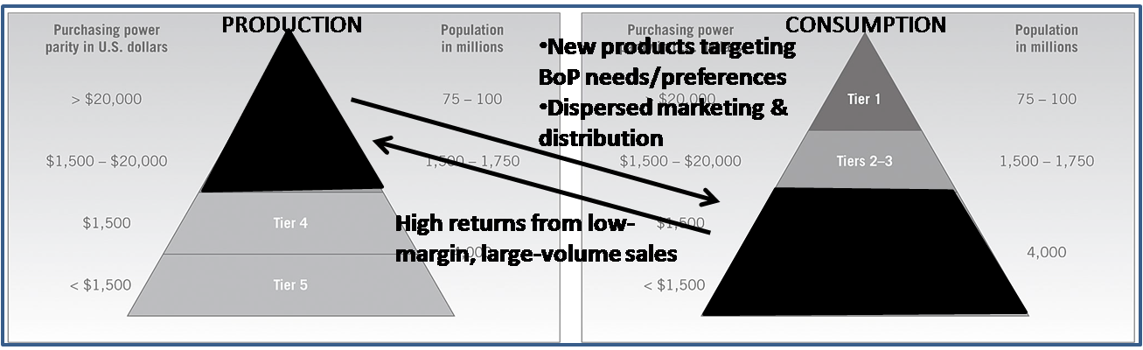

Product Functionality:
- Haier’s small refrigerator also takes cognizance of living space constraints. Due to limited living space, storage is not available for large “family pack” purchases. What does matter to BOP customers is that due to their limited and unstable cash flow, they shop daily and make small purchases.

- Unilever developed in India single-serve sachets of shampoo, which are higher in unit price but make it possible for consumers to buy just the quantity needed instead of a larger, more costly bottle as they are either daily or weekly paid.



Unconventional Business Models

Chit Funds – India (5)
As per a report from IFMR on Chit Funds, most people in smaller towns are attracted to chit funds, because of their easy availability, easy credit and simplicity. Banks are not interested in lending to poor people and poor people see chit funds as the perfect way of getting a loan, even though at a high cost.
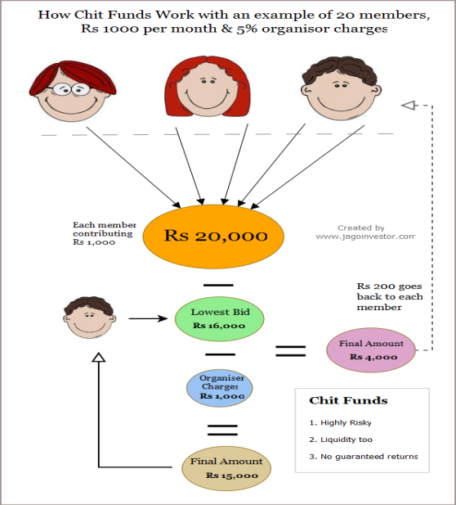

Every month each of the 20 people deposits Rs 1,000. That will make a total of
Rs 20,000 per month. There will be a bid on who will take this money. Naturally there will be few people who are in need of a large amount because of huge expenses, liquidity-crunch and business problems. The person who bids the lowest amount wins. Suppose that three people bid for 18,000, 17,000 and Rs 16,000, the one who bids the lowest will win. In this case it is the person who has bid Rs 16,000. There will also be “organizer charges” which are 5% (standard) of the total amount, so 5% of Rs 20,000 is Rs 1,000. Hence out of the total of 16,000, Rs 1,000 will be deducted and the winner will get only Rs 15,000, Rs 1,000 will be organizer charges and Rs 4,000 is the profit, which will be shared by each member (all 20 people).This amounts to Rs 200 per person, and it will be given to all 20 members.

Wokai.org - China Face book for Farmers

In 2006, the China Banking Regulatory Commission estimated that 2/3 of rural villages, or 480 million people, had no access to formal credit. Only 10 NGOs in China could independently cover the cost of their loans, while in comparison, India had 1000 microcredit institutions at the time. Wokai is a young, online micro-finance program looking to change that imbalance, matching donors with entrepreneurs in China. Potential donors can browse for borrowers by industry, read their profiles and give to a specific borrower. Since its launch in November 2008, Wokai.org has raised US$140 000 in contributed capital and helped over 270 farmer’s drive their enterprises.

Rural Trade -Kirana Stores in India

The rural Indian BOP market is defined as “households in the bottom four expenditure
Quintiles” that spend less than Rs. 3,453 Indian rupees (US$75) on goods and services per month. This definition represents a market of 114 million households, or 76 percent of the total rural population.
In India, retail establishments are often called “kirana” shops. Other than kirana shops, India’s rural retail industry has two more forms: Haats and Melas. Haats are weekly local markets that serve groups of 10-50 villages and sell FMCGs and day-to-day necessities.

Carrefour’s quality line -China

Among the supermarkets in China, Carrefour is characterized by marketing fresh foods. With the rising consciousness of consumers on safety of food, the demand for high –quality, safe food has increased. In 1999, Carrefour started to sell a “green” food supply line under its own brand, with the “Quality Food Carrefour” logo. These lines represent an innovation in the purchasing system within the Chinese context,
Where Carrefour carries out integrated management of the entire supply chain, with full traceability, other retailers are following suit. To date, co-operators of the Carrefour quality line are all larger-scale, rather than the small-scale farmers who account for more than 90 per cent of the agricultural population in China.

Local Community Involvement

The last piece of the puzzle is the local community involvement, creating clusters that include research institutes, NGOs, suppliers and other constituencies which can increase the impact of the innovations in those markets.

One approach is developing “micro-networks” at a local level than can flexibly integrate local suppliers to global platforms that provide expertise and efficiency. A fundamental issue to sort out in local sourcing is reliability (quality standards, volume and technology) and how we can integrate local agricultural producers or entrepreneurs in other areas to be incorporated into the value chain.

Local community involvement can be critical in designing distribution networks. Many companies have developed their networks by integrating local networks of entrepreneurs, especially women, and training them to sell.

Local community involvement can also play a fundamental role in poverty alleviation in these markets by integrating different actors to act as catalysts for change.

Unilever assembled and trained 150 women from 50 villages to directly sell their products to friends or community groups like Avon or Amway do, which marks a radical departure from Unilever’s stratified distribution channels and highly trained sales reps model.

Involving NGOs can also help gain insights and knowledge on the market and facilitate the design of the business model. There is a new breed of market-oriented NGOs that are business and results-oriented. They understand the environment of developing markets and can assist and come up with successful business models. They also understand that the private sector can provide them with sustainability for their organizations and we are seeing this type of partnership developing often.
Opinion and advice can also be obtained by establishing formal advisory relationships with local or regional governments and important local leaders, which in some areas can be even tribal leaders.

DISTRIBUTION NETWORKS

The complexity of low-income markets, especially in geographically dispersed areas, where big retail surfaces are not developed and consumers still prefer buying from small local stores, together with underdeveloped infrastructure, has pushed several players to rethink their distribution strategies.
Developing new distribution channels in BOP markets requires creative and non-traditional approaches.
The quest for innovation in distribution channels has just begun. Distribution networks in
emerging markets tend to be unique and disjointed and Indian rural markets are no exception. As C. K. Prahalad categorically highlights in The Fortune at the Bottom of the Pyramid, “Distribution systems that reach the BoP are critical for developing this market. Innovations in distribution are as critical as products and process innovation.”
- LG, parks its own vans next to general retail kiosks in rural India to make product demonstrations and take orders.
- P&G has created its own distribution network in some rural areas, by financing the purchase of motorcycles to potential “agents”.
- The century-old supply chain of dabbawallahs is operated by 5,000 semi-literate men and women who pick and deliver 200,000 tiffin boxes to office-goers per day.” The average turnover of the Dabbawallah industry is ~$8.5 million per year.

SA Retailers can learn from Indian and Chinese retailers in that we have to invest in a value chain that can get the product to the BOP.

The Indian and Chinese BOP market have provided a foundation for illustrating the following:

Challenges of doing business in South Africa

- Developing a relationship between government, business, labour and civil society to allow for the transfer of knowledge, technology and management skills which are currently held by a minority in the country.
- Employment creation with less Government intervention in terms of Labour Laws as the Chinese are doing.
- Shifting the economy away from the export of primary commodities towards manufacturing.
- Integrating SA firms into global production and supply-chains.
- Black Economic Empowerment (BEE), in terms of real ownership rather than mere control and employment mobility.
- Promoting Small, Medium and Micro Enterprises (SMMEs) development.
- Lessening monopoly power in SA, by creating more competition in terms of product choice and pricing to benefit consumers;
- Corporate social responsibility. Every Company should have policies in place wherby they give back to the communities that support them.
- HIV/AIDS awareness as this will help us maintain a stable workforce and also we will not lose experienced staff.
- Business against crime initiatives to reduce the operating costs of conducting business in an insecure environment.

What influences BOP buying patterns?

Geographic locations

The community will buy from wholesalers and stores that are closest to them and these stores can dictate their terms of doing business.Successful concepts include Shoprtite Usave Stores, Boxer Stores and Cambridge which are located in or around areas frequented by the BOP community.

Where do they work and how are they paid?

Most BOP consumers are weekly or daily paid in a small amount which is rarely banked as they don’t have bank accounts or it is too difficult to do banking.

What do they need the product for?

Selling Twinings Tea to the BOP community is not going to work as the consumer is looking for a basic product at the right price. The same applies to selling washing powder that can only work in a washing machine with hot water. This just adds insult to injury as the BOP consumer does not have luxuries like electricity to have a washing machine or hot water.
Going forward, especially with RDP houses, a new opportunity exists with the introduction of electricity to these homes.

How do you sell to the BOP community?

- Marketing

Marketing has to be unique, as conventional methods may not reach the community.In India it is common to have road shows with dancers for example to market a new product .Traditional radio/TV will not reach the intended market as they don’t have access to this form of media.

- Pricing

Price sensitivity is extremely important when dealing with the BOP community.It is a proven fact that the BOP community pays more for their product when purchasing from local stores as opposed to a Wholesaler/Retailer in the town/city.The Bop consumer has been described as a value buyer.

What does the BOP community buy?

In general, food dominates household budgets at the BOP. Other important items are
Housing, energy, and health care. As incomes rise, the share spent on communication and transportation grows accordingly.
The products and services available to the poor are typically high-priced, low-quality.
In other words it is expensive to be poor. This is partly due to the traditionally limited competition in these markets, since only few companies target them. It also means that there are significant market opportunities for companies in South Africa, which can provide affordable solutions to meet the demand at the BOP.

Successful Bop initiatives in South Africa

The South African market for consumer goods predominantly consists of food & beverages, clothing, furniture, and personal care. Representing 55 % of the average
BOP household expenditure, the market is by far the largest BOP market in South
Africa, but it is also one of the more challenging to enter.
South African Companies are definitely looking at ways of entering the BOP market by partnering with the community:

Massmart
Massmart’s pilot initiative, ASANTE, is allowing the giant retailer to enter the BOP market carefully.Using old shipping containers that are converted into mini supermarkets ,the retailer is able to expand its customer base in rural areas and to get a feel of what the market wants.Each container is managed by 3 woman and by rotating shifts,they can stay open at hours that suit their clientele.It allows them to earn a salary of between R1 500 –R3 000 PM. Bi-weekly meetings are held between the women and the coach in order to provide training and assistance on the essential aspects of running the stores, such as:
• Cash flow
• Stock management
• Advertising
• Bookkeeping
• Placing of bulk orders

The advantage of the ASANTE programme is that the container shop benefits from Massmart’s massive buying power and these discounts can be passed on to the consumer. Currently the program only runs within a radius of 100km from Durban, but the expectation is that if it works, it will be expanded.

Woolworths
The Beaufort West hydroponics initiative has allowed Woolworths to make a significant contribution to a town where unemployment is sitting at 80% by creating employment for 50 people, making it the largest employer in the area. Most significantly, it allows Woolworths to get a guaranteed supply of quality fresh produce, in a sustainable manner.It is not a perfect solution as there have been teething problems, including finance and training but Woolworths sees this project as lucrative enough to roll out to different parts of the country.

SAB-Miller
By partnering with local communities, SAB has guaranteed supply of maize and sorghum, the main ingredients of beer .The farmers get access to the latest methods of farming and a fixed price for their product.The only downfall is the possibility of over -supply which could threaten the price of the product internationally or it could lead to more farmers wanting to supply SAB and a stock shortage.

How can SA businesses apply the “four A’s principle”:

Acceptability
When SA insurance giant Hollard Insurance, entered the funeral plan business, it was seen as a step in the wrong direction. After all what could they possibly know about this market and how could it be profitable? To make the products acceptable, Hollard had to understand the community it was about to serve and the importance of a dignified funeral in the Black Community. Partnering with local undertakers, caterers and hiring companies helped the company to gain a foothold in the local community. Understanding the little things such as the status originating from products and services can be important for developing a business model which truly meets the needs at the BOP. South African companies need to find ways to make their products acceptable to the BOP market. A local Wholesaler who supplies mainly a BOP market says that new products are always slow to reach the BOP market as the supplier/manufacturer does not feel that they have to go out of their way as this market is not their target market.

Awareness
When Danone entered the SA market in the early 1990’s in a joint venture with Clover SA, they realized that they needed a completely new strategy if they wanted to enter the BOP market. They used “Daniladies” - ladies who worked on commission for Danone and went from door to door selling the benefits of yoghurt .This is a unique way of selling the product that has been successful for the company and it shows that a company can do something for a community without just thinking of profits.

Affordability
Pricing is seen as the make or break factor when marketing to the BOP market.As we have seen in products marketed in India, the BOP market, although poor, is extremely brand- conscious. They will buy brand labels as long as they are affordable. Danone realized that, to sell their product, the pricing had to be affordable. Their strategy was called “the single coin project”- R1 for a portion of yoghurt. South African companies need to realize that to do business with the BOP market, pricing has to be right.

Accessibility
Any product that is designed to reach the BOP market must be easily accessible, to the extent that companies have to flood that market with their product. A good value chain needs to be established in partnership with the local community to make sure that your product is readily available.

- SA Business Plan
Why should South African companies focus on the Bottom of the Pyramid consumer?
There are approximately 25 million South Africans who form part of the BOP customers who are underserved, with an estimated spending power of R73 billion a year. Developed retail segments are becoming saturated and with the introduction of foreign players are becoming difficult markets to continue developing organic growth.

“The wider retail sector is becoming increasingly attractive to international investors. South Africa made its debut in A.T. Kearney’s Global Retail Development Index (GRDI) in 2010 as the 24th most popular market for expansion among international retailers owing to its ‘positive long-term economic outlook, large population and an English language base’. The country slipped two places to 26th in the 2011 GRDI, and dropped out of the rankings in 2012 ‘because of market saturation of international retailers compared to other countries in the GRDI’

With the use of the model, we outlined that South African retailers are perfectly situated and equipped to tap into and service the BOP consumer. The model comprises of four quarters that need to be addressed:

- Value Proposition

As outlined , instead of simply adapting foreign/developed market products to BOP markets, successful companies that operate in the BOP segment have been innovative and re-engineered products and services after doing an analysis of local consumers, their habits, preference, needs and ways of living. This can be done at minimal cost and can provide new avenues of very profitable revenue.

This is especially evident in hygiene and “aspirational” products which have a higher cost. To respond to that, Unilever developed in India single-serve sachets of shampoo, which are higher in unit price but make it possible for consumers to buy just the quantity needed instead of a larger, more costly bottle.

a) A Local Initiative

Auto Pedigree is going into previously un-serviced markets with satellite branches that consist of 1 vehicle, 2 staff members and a computer. The satellite branch is serviced by surrounding branches but more importantly it is taking the service offering to the BOP consumer who is now learning about purchasing a vehicle with the help of finance and browsing the service offering on the internet. The idea is to appeal to the ‘aspirations’ of the BOP market, the fact that a person lives in a rural area does not mean that he or she will never be able to afford a vehicle. Compared to a normal Dealership, which can cost R1M to set up, a satellite Dealership requires approximately R100 000 and its running costs are approximately R85 000 per month, which is low compared to R300 000 for a full Dealership. Auto Pedigree has realized that there is a potential market in the rural market, they have to win the trust of the people living there and the business will surely follow. The idea is to educate the people on finance, many think that they could never afford a vehicle as they would have to pay cash and it will take many years to save the money.

Auto Pedigree - Phuthaditjhaba - 3 year projection

 | Year 1 | Year 2 | Year 3
Projected unit sales | 90 | 99 | 109
Projected Gross profit | R1,45M | R1,6M | R1,8M
Projected Expenses | R1,1M | R1,2M | R1,35M
Projected net profit | R320 000 | R400 000 | R450 000

- Business Model

Why are South African companies well poised to service the BOP consumer?
Based on the above point on value proposition and examples provided, it is clear that companies have to re-think and re-design their business models to incorporate aspects of not just new product offerings but new channels of advertising and new methods of revenue collection. For many foreign companies coming into South Africa this will require “unlearning” but for local companies it will require tweaking current models to incorporate the BOP consumer. Many of the local companies have established brands, market knowledge, established networks and know-how which give them an upper hand when entering BOP markets.

“The expansion of retailers into previously untapped areas and the emergence of a black middle class are likely to mean the value of the retail segment increases 47.4% in local currency terms, from an estimated ZAR683.91bn (US$82.68bn) in 2012 to ZAR1.01trn (US$121.90bn) by 2016

a)A Local Initiative
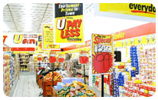
Local retailer Shoprite is an excellent example of a business that has adapted its business model with the introduction of Shoprite U-Save stores, 256 (215 RSA and 41 in Africa) which cater for LSM 1 -5. The U-Save format is a no-frills discounter focusing on lower income consumers. This smaller format store, with a limited range is an ideal vehicle for the Group’s expansion into Africa and allows for greater penetration into underserved areas within South Africa. U Save had a R2.7 billion turnover for the first 6 months ended 2012 and an average turnover of R21 million per store.They have opened 30 new stores and an expected ROI of greater than 20%.
Save-U’s low cost structures enable it to consistently sell comparable products at lower prices than its competitors. In order to gain access to desirable sites, Shoprite is implementing innovative ways of developing stores in conjunction with landowners.

- Distribution Networks

The BOP consumer is located in areas where there are no big retail outlets, poor or non-existent infrastructure and limited distribution channels. The BOP consumer generally has to travel great distances to access products and services. Finding the answer on how to deliver products and services to the BOP consumers will require innovative, creative and non-traditional approaches mainly because they are located in areas that are not easily accessible.

So how do we work around the problem? LG parks its own vans next to general retail kiosks in rural India to make product demonstrations and take orders. Proctor &Gamble has created its own distribution network in some rural areas, by financing the purchase of motorcycles to potential “agents”
Locally the answer may be very simple. The consumers travel to retail outlets currently, in many cases by taxis. There in may lay the solution, if partnerships are developed with Taxis that operate in these areas. Whilst transporting these BOP consumers they can transport products to retail outlets to supplement their income. Retailers get access to BOP consumers and there is a cheap distribution network with limited upfront investment.

- Local Community Involvement

Profitability in servicing the BOP consumer will ultimately come with maximising the supply chain in these areas and the integration of the local community can create market acceptance, keep costs low and help fast track the innovation process. The approach businesses should look at employing is one of creating “Micro Networks” at the local level they integrate local suppliers so as to provide the farmers with efficiencies and in return get their expertise and market knowledge.
Examples of this happening locally are the ASANTE project run by Massmart, Woolworths Beaufort West Hydroponics initiative, SAB-Miller programme and Shoprite-Freshmark.
Freshmark started out as a way for Shoprite to secure fresh produce but has turned into its fruit and vegetable procurement and distribution arm and is a substantial business in its own right. It not only supplies fresh produce to the Groups stores within South Africa, but also to most of its outlets in other parts of the continent. Currently it is one of the largest buyers of fresh produce in South Africa. Freshmark also imports fruit and vegetables to ensure a wide variety and continuity of traditionally seasonal fresh produce. In the 2012 financial year, Freshmark handled 320 000 tons of fruit and vegetables.

“The majority of our produce requirements are sourced as far as possible directly from local producers with the focus on a fresh promise to the customer. This practice also reduces transport and packaging costs and unnecessary handling through the use of returnable plastic crates”.

It operates its own network of distribution centres and refrigerated trucks; negotiates production contracts with some 459 large- and small-scale farmers in South Africa as well as 354 suppliers in the 11 African countries we operate in, sources specialty fruit and vegetables on international markets, and plays a key role in equipping emerging farmers with the knowledge and skills to produce and meet international GLOBAL G.A.P. standards”

Conclusion

Servicing the BOP consumer does not fit in with traditional models and the successful retailers in this market have realised that they have to put in the work initially but can make very profitable returns from servicing the BOP consumer. Servicing the BOP consumer requires innovation and creativity, much less than that required to continue competing in the developed retail segments that now include International Juggernauts.
The answers may be as simple as supplying your product in sachets instead of bottles and having a Taxi deliver your goods to your store run in partnership with a local community member.

The value lies in that with the rate of Urbanisation and the aspiration of the BOP consumer, when these customers move out of their market segment and upwards, they may prove to be very loyal customers if they initially find your product in their traditional markets.

To help the local retailer determine if they have what it takes to reap the rewards of the BOP community, we have designed a check-list:

BOP Criteria | yes | no
Do you have a product that can meet the needs of the BOP community?
Are you prepared to take a long-term view on profitability?
Can you afford the upfront investment to do market research and product development?
Are you prepared to re-engineer your business model to include the BOP?
Are you prepared to re-engineer your distribution network?
Do you have the expertise and resources to market and communicate to the BOP market?
Do you fulfill the criteria’s of:
- Acceptability
- Awareness
- Affordability
- Accessibility
Do you have the means to track the costs and sales that arise from the BOP community?

The poor cannot remain destitute indefinitely, the business world is watching, Africa is the investment song and if local business does not adequately cater for all segments of the market expect new entrants of robust entrepreneurs from growing economies like China and India to penetrate the retail segment servicing the BOP consumer in view these consumers is already accustomed to a large manufactured product offering from both these countries.

Reflections on the ALP Process - Vinay Singh

Let me start by saying that the ILDP has been an incredible journey that started in South Africa, continued in China and India, and concluded back in South Africa. In many ways it has been a learning curve for me and also my Team Members. The lessons learned have been very practical, in fact I currently am making use of information that I have picked up along the way.

As the Team Leader, I have learnt to become a more patient person; I now realize that that it is important to listen to all points of view, even if you do not agree. Team work has led us to achieve success in our Action Learning Project.

The greatest challenge for me was that I did not understand what the BOP market was and how could us as Retailers do for them? Once I started researching the topic, my eyes opened to a new world, should I say an opportunity. I did not realize that there are approximately 5 Billion people in the world that are regarding as the BOP community, people that survive on less than R9-R27 per day, little did I know that they are on my doorstep.
I learnt that being a BOP does not mean that I do not have aspirations and dreams, if anything I dream bigger and work harder. South African Retailers are definitely doing their part to service this community, in my opinion a lot more than the Chinese and Indian, in fact I will say that the South African Government is putting a lot of effort into reducing the number of BOP members.
Unemployment in South Africa is at drastic proportions; roughly 25% of the country collects some form of Social grant. As Retailers, these figures may look mind boggling, but if we look deeper we see the opportunities for us all. The amazing projects that are out there is testament to the fact that all South Africans are opening their hearts and their pockets and giving back to communities.
Kids that were born and raised in poverty have gone on to complete their tertiary education and have not forgotten their roots. They are going back to their old communities and investing their time and training into the youth.
If all South Africans can think this way, let’s give back to the community that grew us up, fed us, educated us and supported us, I know that I will.

In conclusion, a very special thank you to Bonita, whose support and insight has helped us achieve a fantastic ALP, your coaching method helped us learn by mistakes and we learnt to apply what we learnt in the classroom.
Reflection on ALP Process – Sagren Pillay

In terms of the ALP topic itself, I was exposed to an opportunity that is available at the bottom of the pyramid (BOP) that we have not yet begun to realise. As a retailer, we spend large amounts of money on marketing and customer research but have been oblivious to the opportunity that exists with regards to servicing the BOP consumer and the perfect position we occupy in the market to service this customer. The BOP customer is loyal and as they aspire to move up in life, they will continue to support our organisation and we will grow with them.

Previously if you asked me, how would you cater for the BOP community?
My response would have been, let’s take our best selling products and knock back the quality and make it as cheap as possible.
What a misconception, we have discovered that ‘PRICE’ is not the highest ranked prevailing criteria for the BOP consumer. In fact Price and Quality are points of parity and the BOP consumer needs functional products that have been well thought out to service their needs on a daily/weekly basis that takes into account their circumstance/lifestyle.

I have learnt that there can be success at the BOP and the way to attain success for my business is to adopt a strategy that uses the following four elements:
- What’s our Value Proposition?
- How does our Business Model evolve to cater to the BOP consumer?
- What can our Distribution Networks offer?
- How do we Focus on and Involve Local Communities?
Doing business at the BOP is a long-term business strategy and not about turning a quick buck but more about building relationships. I can now also present a substantiated business case to encourage the development of more products and services for the BOP customer in my organisation.

The learning’s that I am applying in my work environment are: innovation, creativity, simplicity, understand your customer and most importantly “Unlearn to Relearn”. The ALP has helped me become a better merchant in my business because I now think of several ways to solve a problem I am faced with. The exposure to the India and China markets have opened my mind up to revolutionary and simple ways to find inexpensive solutions to complex problems I face in my current work environment.

Team dynamics during the ALP process has thought me patience and that I need to listen as much as I speak. The technical knowledge I received during the process/programme has developed me into a dynamic leader that is valued in my organisation. I have the confidence and technical knowledge to present my point of view in a professional and dynamic manner. The process will assist me in achieving my goal of an executive position in my organisation.

Reflection on ALP Process - Naresh Soorajpal

My thanks go firstly to the Wholesale and Retail Seta for giving me an opportunity to participate in this prestigious programme. This has been an enduring programme which has tested my mental and physical strength and it would not have been possible to have completed this without the support of my family, friends, colleagues and most of all the delegates and academic staff of GIBS.

The ALP process started nine months ago, where through a vote off system we were given our topic of What can SA Retailers learn from India and China in capturing opportunities that present themselves at the bottom of the pyramid?

The next phase of discussions automatically lead to the countries we were going to visit, this brought about lots of excitement and enthusiasm in view that I was being given a golden opportunity to immerse myself and have practical experience on the topic itself.

The actual ALP process has grown me, teaching me to stretch my thinking ability as opposed to, only looking at the current environment. This did not come easily, but with the thinking process of first “unlearning” and then starting to learn helped me to look at the subject with an open mind when I visited India and China.

The practical experience of investigative research has allowed me to see the different views that are held on the subject, coupled with research methodology and the actual experiences locally and internationally the ALP process has been a social exchange programme from which we have learnt from one another, applied our experiences and found a way forward.

Syndicate work has been a key player in understanding the perceptions of team members as well as creating an avenue to work within a team, important lessons learnt here were patience, allowing members to voice an opinion, but most important was the opportunity to grow each other in thinking patterns.

My learning’s during the modules prepared me to look at the ALP holistically whereby I was able to grow my own knowledge and apply this to existing thinking and work patterns.

The ALP process has culminated in the presentation of a business case study which has been supported by theoretical examples and arguments including experiences during local and international immersions, which has the possibility of being applied within the local market.

In conclusion the ALP process has been strategically significant in my career path.

Reflections on the ALP process - Sindy Naidoo

What can S.A. Retailers learn from India and China in capturing opportunities that present themselves at the bottom of the pyramid (BOP)?

Team 2 known as African Innovative Retailers came together in June 2012. My first impressions of the topic focused on Chinese entrepreneurs in South Africa capitalizing on the purchasing power of the middle and lower income people. As we progressed with the project, it was not the growing middle class that caught our attention but the rising and aspirant BOP. Unpacking the BOP revealed a need that most retailers have not considered.

The action learning project brought team dynamics into play, however with the help of personal mastery skills and colour charts to identify the individuals key strengths, teams went through the storming phase. This was a critical lesson with team cohesiveness and understanding the culture which we experience daily in the workplace. The storming phase taught me to be open and honest in expressing myself. I recall Vinay, the team leader telling me in one session that I delivered a ‘power punch’! Unpacking the concerns and arriving at an amicable solution was a satisfactory outcome. Through the ALP I learned each member’s key strengths and was truly amazed at the transition of one member.
My first travel experience to China and India, the most densely populated countries in the world rich with culture and heritage. These countries resonate the feeling of the South African people steeped in tradition and culture and the desire for self -improvement. Customer centricity is evident in both these countries. The friendliness and insight into the products offerings as well as a willingness to please the customer is what made this trip one of the memorable experience.
India has capitalized on the Bottom of the Pyramid as an emerging market. Dharavi slums, Mom and Pop stores bear testimony to the booming industry. In South Africa we have an emerging Bottom of the Pyramid market in rural and low income areas. Retailers need to tap into this market which will create a triple fold return (especially to achieve Broad Based Black Economic Empowerment targets) by investing in the community through Corporate Social Investment and Enterprise Developments, purchasing goods especially fresh produce from the communities they helped set up and lastly make commodities accessible to the community who often pay premium prices.
Overall I have learned you cannot be an “Island on to yourself” especially when working with a team. A shift of the mindset is required which lead me to: LEARN, UNLEARN AND RELEARN. Thank you to my team members for adding to my teachings and new friendships.

Reflections on ALP – Lorraine Singh

Being part of this prestigious ALP team of 2012 has been a privilege .and a life changing experience for me. I would like to take the opportunity my colleagues in my team African Challenges. The ALP has been incredible and has had a meaningful impact on both my personal and professional life.
The set objectives, I’m proud to say that the ALP has met and exceeded my expectations. These are some of the key learning’s:
- Agility and Context is important –Learning in India and China
- Scenario & Strategic thinking e.g. Key learning’s In China, the government has different , proven to deliver on better the GDP
- Lateral thinking , Slum visited in Dharavi (India) the opportunity in S.A
- Group Dynamics & Teamwork, in the ALP and at work as well. Understanding pressures daily, however assisting each other when and where one can, ensuring that results are attained.
- Personal Mastery& Leadership understanding myself, my strengths and working in teams(Members,Vinay,Naresh,Sindy,Sagren )

The exposure to international players, China and India, has exposed to best practices from the East .China European International Business School (CEIBS) assisted in ALP after hours spending time with the professor looking at the BOP and asking questions pertinent to the ALP. The ALP brought the team together; we got different perspectives from leaders of organizations in China. Some of the businesses we visited and met with, Beijing Axis, Semir Clothing, 360 Buy, Wu Mart in China. Among the supermarkets in China, Carrefour is characterized by marketing of the fresh foods. Consumers are very conscious on the safety of food. The demand for high quality and safe food has increased in China. In 1999, Carrefour started to sell a “green” food supply line under its own brand with the “Quality Food Carrefour” logo. These lines represent an innovation in the purchasing system within the Chinese context. This was quite profound findings for the ALP, as our work was on the BOP.
To date, co-operators of the Carrefour quality line are all larger-scale, rather than the small-scale, farmers who account for more than 90 per cent of the agricultural population in China.

In India, a humbling experience to visit one of the biggest Slums in the world, Dharavi. Great learning’s here on collaborating, effective networking and innovation. In India, retail outlets are often called kirana stores. Other than kirana shops, India’s rural retail industry has two more forms: Haats and Melas. Haats are weekly local markets that serve groups of 10-50 villages and sell FMCGs and day-to-day necessities. This was evident travelling the streets of Mumbai on the investigation of the ALP.

Prahalad and Hart,2002-“Fortune at the Bottom of the pyramid”
Prahalad and Hart,2002-“Fortune at the Bottom of the pyramid”
Strategy-business.com,2002 CK Prahalad and Hart
World Resource Institute
World Resources Insitute-2007,Chapter 1
National Sample survey Organisation-India
Based on an average daily income of R8
Business monitor international-South Africa Retail Report Q3 2012
Victoria Kemanian -Unlocking Value at Bottom of the Pyramid Markets 2007
Information supplied by W Marais-Auto Pedigree
Business Monitor International - South Africa Retail Report Q3 2012
Shoprite website-USave Stores
Victoria Kemanian -Unlocking Value at Bottom of the Pyramid Markets 2007
http://www.shopriteholdings.co.za/pages/1019812640/retailing-services/Freshmark.asp
http://www.shopriteholdings.co.za/pages/1019812640/retailing-services/Freshmark.asp

