

Guidelines on how to register as SDF and complete
WSP/ATR forms for less than 50 Employees

Table of Content

1. REGISTER AS A NEW SKILLS DEVELOPMENT FACILITATOR (SDF) 3
2. ACCESSING THE SYSTEM 5
3. REGISTER OR REMOVE AN EMPLOYER 8
4. EDIT SKILLS DEVELOPMENT FACILITATORS (SDF) DETAILS 9
5. ACCESSING ORGANISATION INFORMATION 10
6. GUIDELINES ON HOW TO COMPLETE WSP/ATR FORMS 11
6.1 Organisation Info 11
6.2 Organisation Info 12
6.3 SDF 12
6.4 WSP Plan and Report 13
7. ACCESS TO THE FORMS 14
8. HOW TO COMPLETE THE ATR FORMS FOR LESS THAN 50 EMPLOYEES 14
Annual Training Report Form (1 April 2012 – 31 March 2013) 14
Vacancies difficult to fill (1 April 2011 – 31 March 2012) 15
Variance Report (1 April 2011 – 31 March 2012) 15
Total Actual Budget (1 April 2011 – 31 March 2012) 15
9. HOW TO COMPLETE THE WSP FORMS FOR LESS THAN 50 EMPLOYEES 16
Banking Details 16
SME WSP Form (1 April 2012 – 31 March 2013) 17
Total Projected Budget (1 April 2012 – 31 March 2013) 17
Organisation Linkages form 17
Approval Checklist 18
10. PRINT REPORT 19
11. GRANTS AND LEVIES 20

REGISTER AS A NEW SKILLS DEVELOPMENT FACILITATOR (SDF)

Step 1: Go to W&RSETA’s Website: www.wrseta.org.za
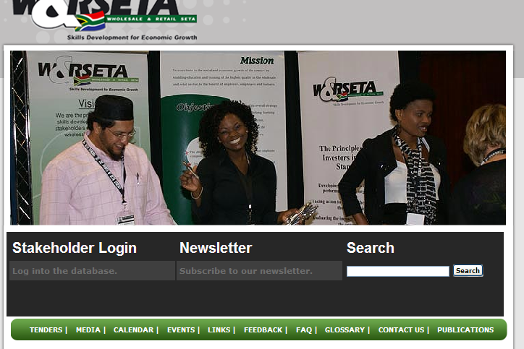

Step 2: Click on the "Stakeholder Login” Option

Step 3: Click on the "Register as a Skills Development Facilitator" option

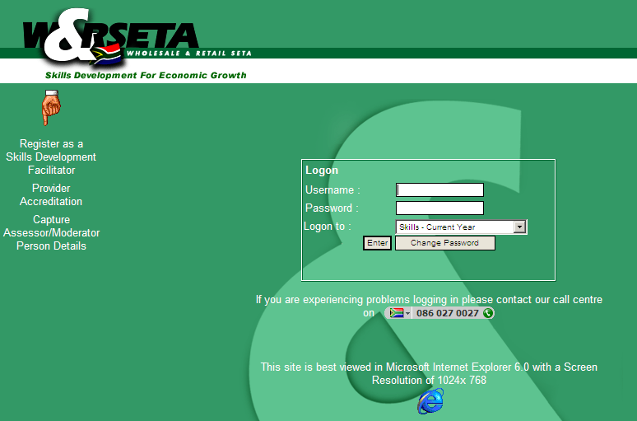

Step 4: Fill in the information on the registration form
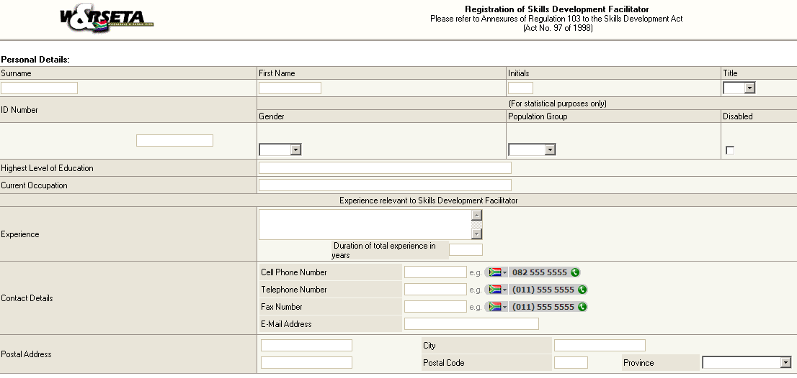

Step 5: Click on the "Enter" button on the bottom of the page to go to Step 2.
Step 6: Fill in the required information.
Step 7: Click on the "Enter" button at the bottom of the page. If your pop-up blockers are on please hold the control key down, press enter and then let go of the key
Step 8: The system will confirm the registration. It will give a summary of your details.
Step 9: Click on the "Register an Organisation" button at the bottom of the page
Step 10: ¹ Fill in the L number that you want to link to your profile, in the "SDL Number” field.

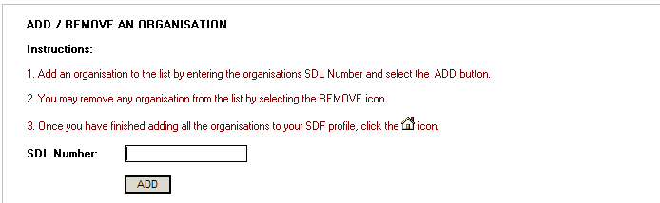

Step 11: ² Click on the "Add" button.

NOTE 1: To add another organisation repeat Step 10 and Step 11 above.
NOTE 2: You will need to type in a username and password with more than 5 characters. You are going to use this username and password to logon to the system.
NOTE 3: A pending login status indicated that the SETA needs to accept your registration before you are granted access to an organisations workplace skills plan.

ACCESSING THE SYSTEM

Step 1: Go to W&RSETA's Website: www.wrseta.org.za

Step 2: Click on the "Stakeholder Login” Option

Step 3: Fill in your username and password.

Step 4: Select "Skills - current year" from the dropdown menu
Step 5: Click on the "Enter" button.
Step 6: Click on "Yes" on the next screen.

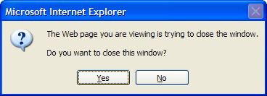

Step 7: The Skills Development Facilitators Dashboard will open.
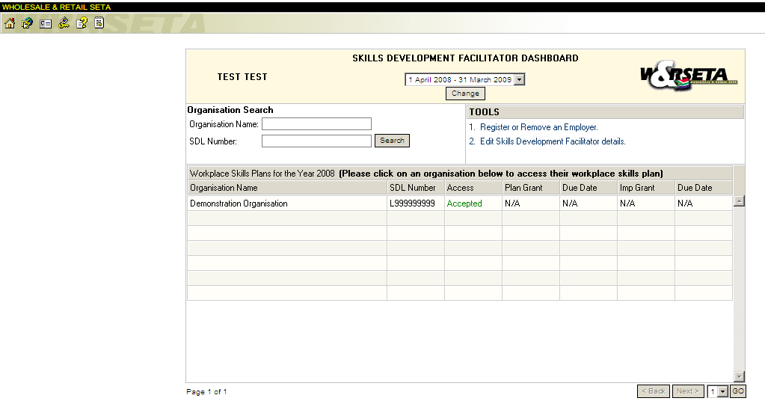

REGISTER OR REMOVE AN EMPLOYER

Step 1: Click on "Register or Remove an Employer"

Step 2: To Remove an Employer click on the red cross under "Options"

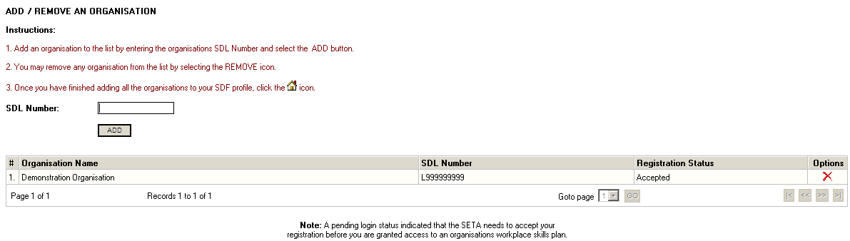

Step 3: To add an Employer fill in the L number in the "SDL Number" field and click
on the "Add" button.

Step 4: Once you have finished adding all the organisations to your profile click on
the "House" icon

EDIT SKILLS DEVELOPMENT FACILITATORS (SDF) DETAILS

Step 1: Click on "Edit Skills Development Facilitators Details"

Step 2: Change the information.

Step 3: Click on the "Enter" button at the bottom of the page.

Step 4: Once you have finished adding all the organisations to your profile click on
the "House" icon

ACCESSING ORGANISATION INFORMATION

Step 1: Click on the company that you want to access from the list of companies that
are listed in your profile.
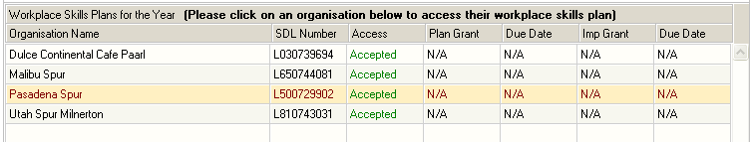

Step 2: The system will open on the "Organisation Info" screen.

Step 3: There are 8 different screens: Organisation Info, Org Contacts, SDF, WSP
Plan and Report, Document Uploads, Training Committee, Grants & Levies, and Linked SDF

GUIDELINES ON HOW TO COMPLETE WSP/ATR FORMS

Please ensure once the forms have all been completed and the document is signed, the user must login and click on the “Submit” button under the WSP forms. The ISDF will not be able to submit after the 30th of June 2012

Organisation Info

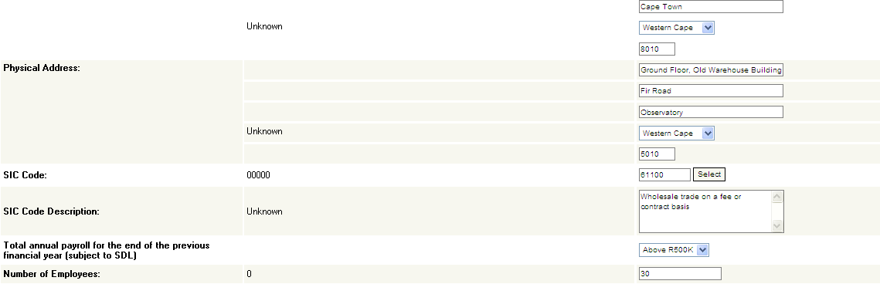

The first screen is the screen with the Organisation Information. Please note that the information on the left is the information that we receive from the Department of Higher Education to upload onto the system. This information can not be updated. If you need to update the information of the organisation you can do it on the right side of the screen which is the W&RSETA DATA. Please ensure you check that the number of employees is correct as this influences the type of forms generated.

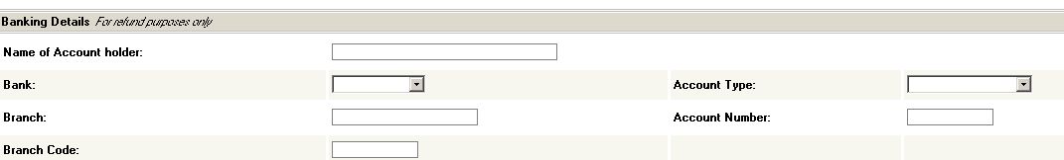

You can add/update the banking details for the organisation on the Organisation Info tab. The Company CEO/MD/Owner details are mandatory fields which need to be completed before the information is saved.

Remember to click on the “Enter” button of the page to save the change that you’ve made. You will need to confirm the information before the WSP can be created.

6.2 Organisation Info

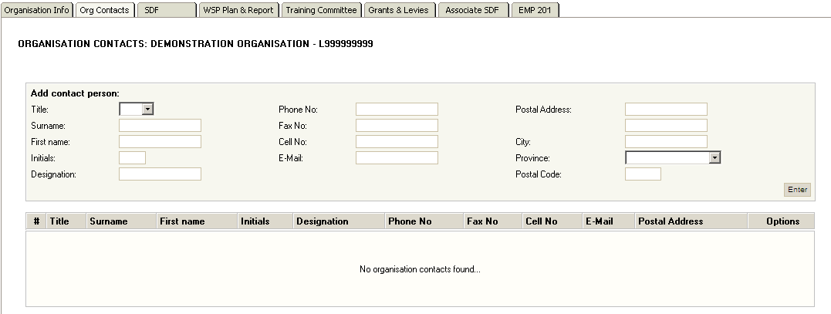

It is important for the SETA to have the contact details of the persons in the organisation. The reason for this is to be able to communicate with the relevant people of the organisation when the SETA wants to send out invitations to workshops or other functions.

Please ensure that the contact details are correct and confirm the details before opening the new WSP forms

6.3 SDF

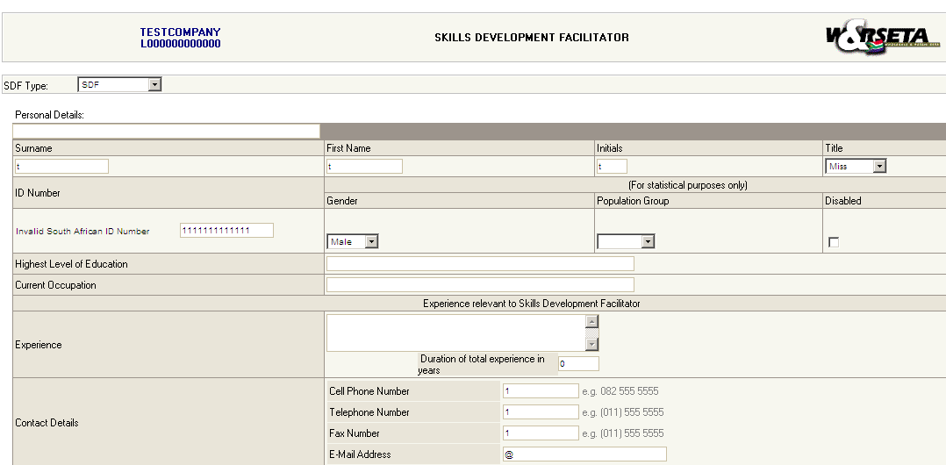

The Skills Development Facilitator (SDF) can also edit their information on this screen. Remember to click on the “Enter” button to save changes.

Please ensure that the SDF type is correctly specified:
- SDF – Skills Development Facilitator
- ISDF – Independent Skills development Facilitator
- Secondary SDF – This user will only have viewing access to the organisation.

6.4 WSP Plan and Report

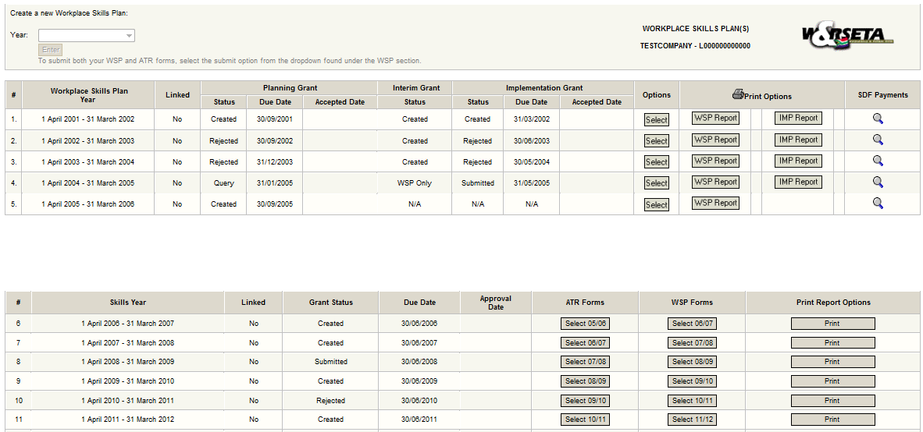

This is the main screen for WSP’s.

Create a new Workplace Skills Plan

Click on the “Year” dropdown box, select the year that you want to create the Workplace Skills Plan and click on the “Enter” button. There will be a pop-up to confirm the number of employees for the organisation. This needs to be completed before the forms are created. Once you click on update the WSP forms will create.

If the year does not appear in the dropdown box, it means that the WSP has already been created and that you don’t need to create it again. You will select 2012 – 2013 for this submission.

Information

After the WSP has been created you will be able to see the following information:
      - The Workplace Skills Plan year
      - Linked Status
      - Status of the Planning Grant
      - Due Date of the forms
      - Approved Date of the forms
      - ATR forms
      - WSP forms
      - Print report option

ACCESS TO THE FORMS

To access the forms of the Annual Training Report (ATR) or Workplace Skills Plan (WSP), click on the “Select” button. This will take you through to the WSP forms that you need to fill in. Select 11/12 will take you to the ATR forms, Select 12/13 will take you to the WSP forms.

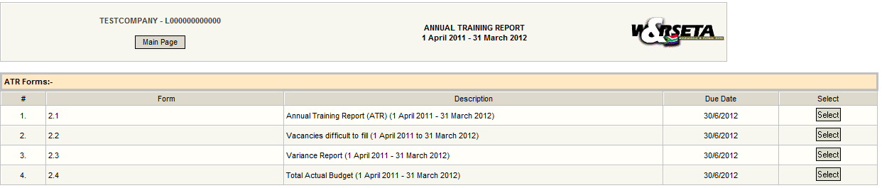

Click on the Select button next to the form that you want to fill in the information to access this form.

HOW TO COMPLETE THE ATR FORMS FOR LESS THAN 50 EMPLOYEES

The ATR section comprises of 4 forms for less than 50 employees. This is:
- Annual Training Report form (1 April 2011 – 31 March 2012)
- Vacancies difficult to fill (1 April 2011 – 31 March 2012)
- Variance Report (1 April 2011 – 31 March 2012)
- Total Actual Budget (1 April 2011 – 31 March 2012)

Please note the OFO code version 2011 is being used for the ATR forms

Annual Training Report Form (1 April 2012 – 31 March 2013)

The SME ATR form will display all the records completed for the 11/12 WSP from the previous submission. The user needs to check the employees were the ones trained, the user has an option to edit or delete the line items. The user can also add additional employees trained.

Click on the search box to find the OFO code

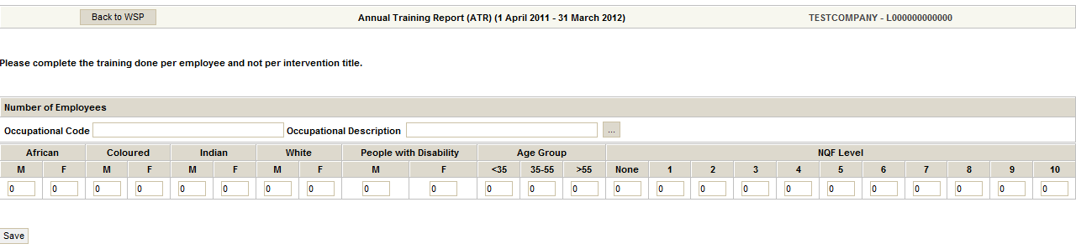

Vacancies difficult to fill (1 April 2011 – 31 March 2012)

The functionality to this form is similar to the Annual Training Report. Click on the search option.

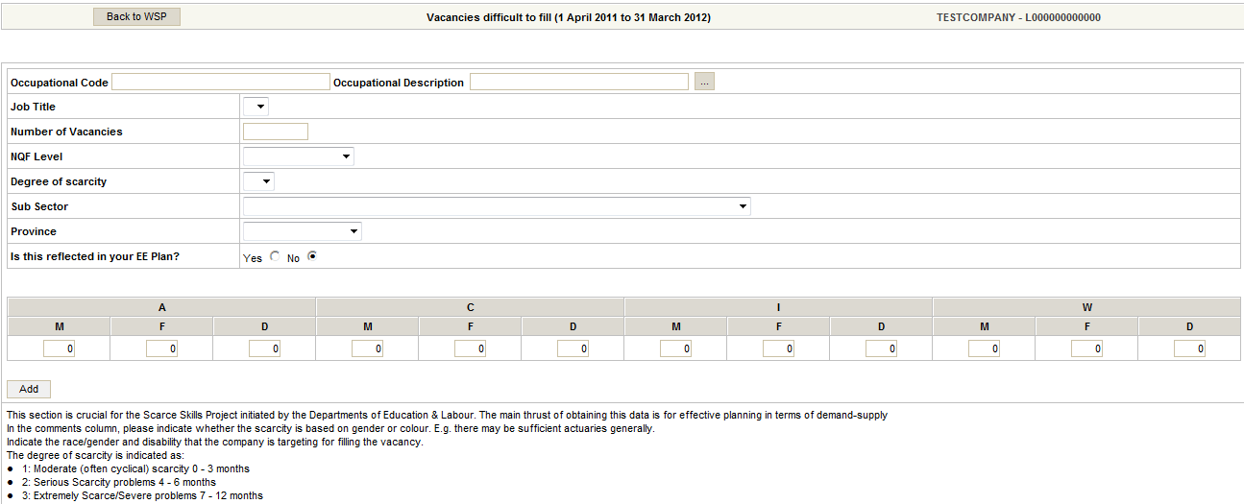

Select the OFO code and complete the Job Title based on the specialisation of the OFO code selected, NQF level, Degree of scarcity, Sub sector, Province and if it reflects on the EE plan.

This information will be used to review the scarce list within the sector.

Variance Report (1 April 2011 – 31 March 2012)

This form pulls through the OFO code totals captured in form 1.1 SME WSP form for 2011/2012 and 2.1 SME ATR form for 2011/2012.

The user needs to select the reason for the variance in the numbers per OFO code.

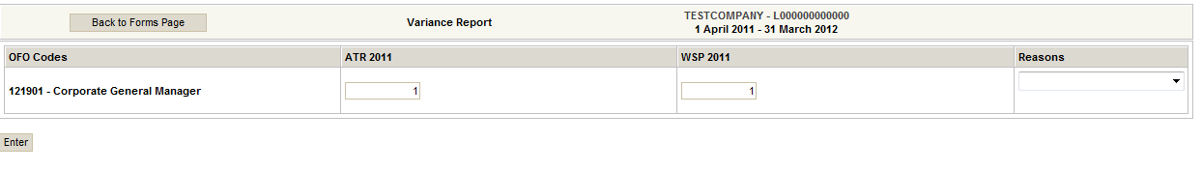

Total Actual Budget (1 April 2011 – 31 March 2012)

The user needs to complete the total amount spent on training for 2011/2012.

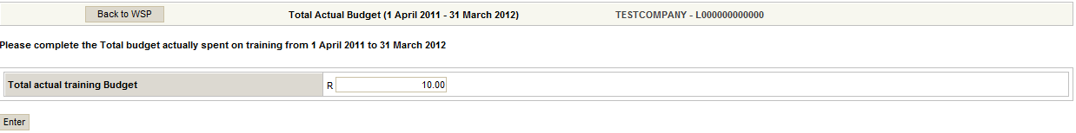

9. HOW TO COMPLETE THE WSP FORMS FOR LESS THAN 50 EMPLOYEES

The WSP section comprises of 5 forms for less than 50 employees. These are:
- Banking Details
- SME WSP Form (1 April 2012 – 31 March 2013)
- Total Projected Budget (1 April 2012 – 31 March 2013)
- Organisation Linkages
- Approval Checklist

Banking Details

This form serves to identify whether the banking details of an organisation has changed or not. If the details have change a cancelled cheque must be submitted with the signed WSP
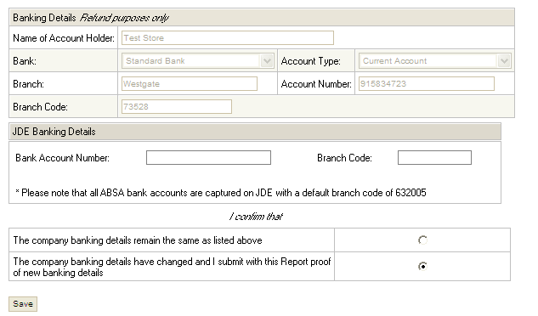

SME WSP Form (1 April 2012 – 31 March 2013)

The SME WSP form will address the employees to be trained. The user needs to complete the information.
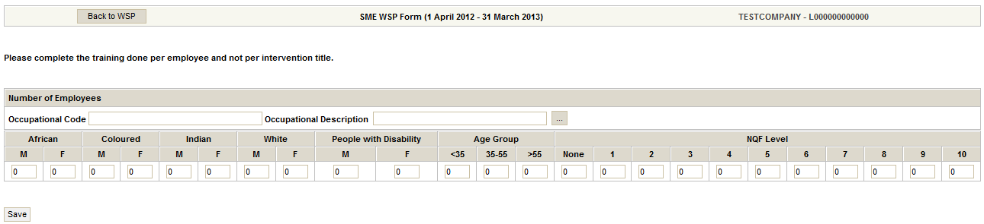

Total Projected Budget (1 April 2012 – 31 March 2013)

The user will complete the total planned amount for training for financial year 2012/2013.

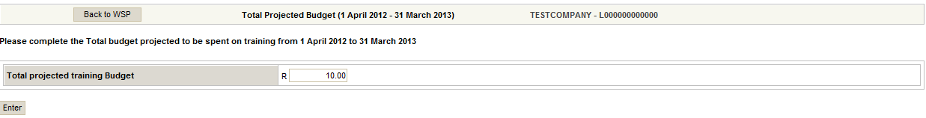

Organisation Linkages form

This form identifies the current organisation linked to the parent organisation for which the WSP/ATR is being completed. The user needs to check if the number of employees per child organisation is correct and update the records within the form. This detail will automatically be updated in the child organisation profile.

If there are organisations that should be linked for the financial year and are not currently in this form, a template is available on W&RSETA’s website which needs to be completed and submitted with the WSP/ATR document. The linking will be done buy the seta official.

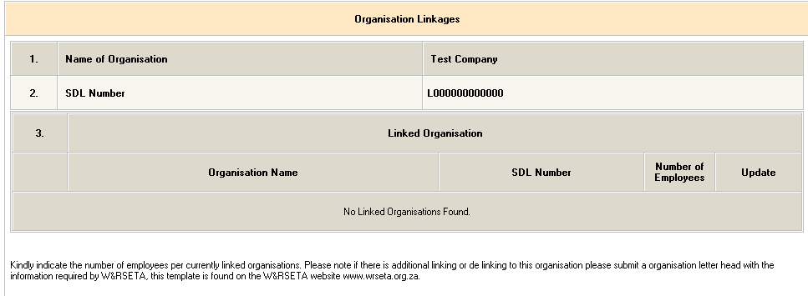

Approval Checklist
This form serves to check all the fields that are applicable to the organisations before submission is done.
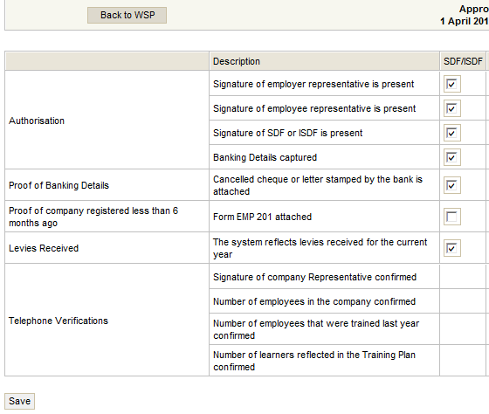

PRINT REPORT

Once the WSP/ATR forms have been completed, you click on the “Print Report” button the system will generate a report of all the information that has been captured on the ATR and WSP forms. You will be able to copy this document to Microsoft Word.

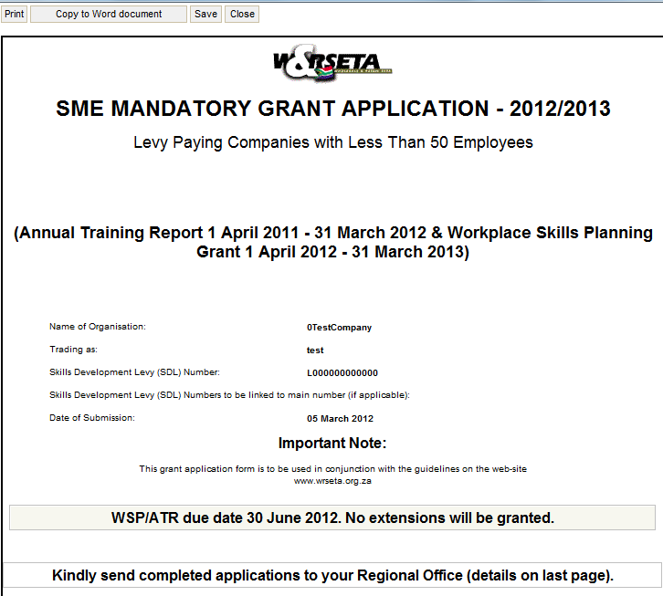

GRANTS AND LEVIES

This screen allows you to trace the levies been paid by the company to the SETA and the Grants that’s been paid be by the SETA to the organisation.

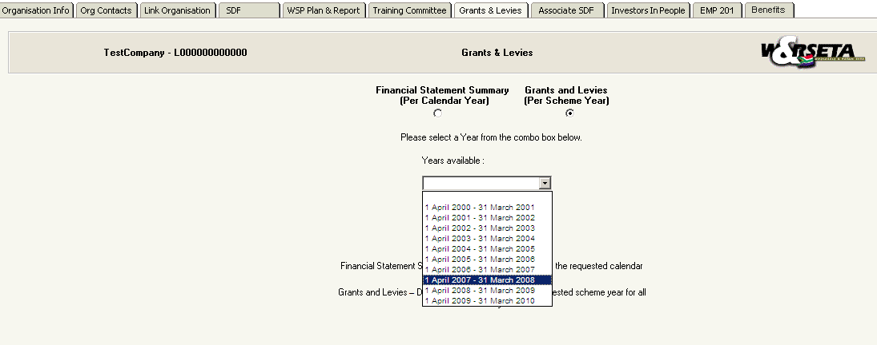

You can view the information in 2 ways.
    - The Levies paid on one screen and the Grants received in one statement, or,
    - In a Financial Statement Format with the Levies paid on the one side and the Grants received on the other side.

